## Contents

|  |  |  |  |  |  |
| --- | --- | --- | --- | --- | --- |
| Entry # | Week | Type | Date | Time | Hours |
|  | 1 | Week 1 Workshop | 28/2/23 | 12pm | **2** |
|  | 1 | Self-directed | 28/2/23 |  | **2** |
|  | 2 | Kick-off meeting | 6/3/23 | 6pm | **2** |
|  | 2 | Kick-off mentor meeting | 7/3/23 | 11am | **1** |
|  | 2 | Self-directed | 7/3/23 |  | **1** |
|  | 2 | Week 2 Workshop | 7/3/23 | 12pm | **2** |
|  | 2 | Self-directed | 8/3/23 |  | **2.5** |
|  | 3 | Week 3 mentor meeting | 14/3/23 | 10am | **1** |
|  | 3 | Team meeting | 14/3/23 |  | **2** |
|  | 3 | Week 3 Workshop | 14/3/23 | 12pm | **2** |
|  | 3 | Self-directed work | 14/3/23 |  | **1.5** |
|  | 3 | Client meeting | 16/3/23 | 1pm | **1** |
|  | 3 | Team meeting (online) | 18/3/23 | 9am | **2** |
|  | 3 | Self-directed work | 19/3/23 |  | **4** |
|  | 4 | Self-directed work | 20/3/23 |  | **3** |
|  | 4 | Team meeting | 21/3/23 | 9.30am | **0.5** |
|  | 4 | Week 4 Mentor meeting | 21/3/23 | 10am | **1** |
|  | 4 | Team meeting | 21/3/23 |  | **1** |
|  | 4 | Week 4 Workshop | 21/3/23 | 12pm | **2** |
|  | 4 | Self-directed work | 22/3/23 |  | **3** |
|  | 4 | Self-directed work | 23/3/23 |  | **6** |
|  | 4 | Team meeting (online) | 25/3/23 | 9am | **3** |
|  | 5 | Self-directed work | 27/3/23 |  | **3** |
|  | 5 | Week 5 mentor meeting | 28/3/23 | 9.30am | **2** |
|  | 5 | Self-directed work | 28/3/23 |  | **2** |
|  | 5 | Week 5 Workshop | 28/3/23 | 12pm | **1** |
|  | 5 | Self-directed work | 29/3/23 |  | **3** |
|  | 5 | Team meeting (online) | 1/4/23 | 9am | **2** |
|  | 5 | Self-directed work | 1/4/23 |  | **2** |
|  | 6 | Week 6 mentor meeting | 4/4/23 | 10am | **1** |
|  | 6 | Proposal presentation | 4/4/23 | 2.30pm | **1** |
|  | 6 | Team meeting (online) | 8/4/23 | 9.30am | **2** |
|  | 7 | Self-directed work | 11/4/23 |  | **4** |
|  | 7 | Upskilling | 12/4/23 |  | **3** |
|  | 7 | Upskilling | 14/4/23 |  | **3** |
|  | 7 | Upskilling | 15/4/23 |  | **3.5** |
|  | 8 | Upskilling | 17/4/23 |  | **2** |
|  | 8 | Upskilling | 20/4/23 |  | **2** |
|  | 8 | Mentor meeting (online) | 21/4/23 | 3.30pm | **0.5** |
|  | 8 | Team meeting (online) | 22/4/23 | 9.30am | **1** |
|  | 9 | Upskilling | 24/4/23 |  | **2** |
|  | 9 | Upskilling | 25/4/23 |  | **1** |
|  | 9 | Upskilling | 26/4/23 |  | **2** |
|  | 9 | Team meeting | 29/4/23 | 9.30am | **3** |
|  | 9 | Upskilling reflection | 30/4/23 |  | **1** |
|  | 10 | Week 8 mentor meeting | 2/5/23 | 9.30am | **1** |
|  | 10 | Team meeting | 2/5/23 | 12pm | **1** |
|  | 10 | Self-directed work | 2/5/23 |  | **2** |
|  | 10 | Self-directed work | 5/5/23 |  | **1** |
|  | 10 | Team meeting | 6/5/23 | 9.30am | **1.5** |
|  | 10 | Self-directed work | 6/5/23 | 12pm | **2** |
|  | 11 | Week 9 mentor meeting | 9/5/23 | 9am | **1** |
|  | 11 | Team meeting (online) | 12/5/23 | 4pm | **2** |
|  | 11 | Team meeting (online) | 13/5/23 | 9.30am | **2** |
|  | 12 | Week 10 mentor meeting | 16/5/23 | 10am | **1** |
|  | 12 | Team meeting | 16/5/23 | 11am | **2** |
|  | 12 | Mid-term review Workshop | 16/5/23 | 3pm | **1** |
|  | 12 | Self-directed work | 17/5/23 | 2pm | **3** |
|  | 12 | Self-directed work | 19/5/23 | 5.30pm | **2** |
|  | 12 | Self-directed work | 20/5/23 | 1.30pm | **2** |
|  | 12 | Self-directed work | 21/5/23 | 10.30pm | **3** |
|  | 13 | Team meeting | 23/5/23 | 9.30am | **3** |
|  | 13 | Week 11 mentor meeting | 23/5/23 | 2pm | **1** |
|  | 13 | Self-directed work | 23/5/23 | 4.30pm | **2** |
|  | 13 | Self-directed work | 25/5/23 | 6.45pm | **0.5** |
|  | 13 | Team meeting (online) | 27/5/23 | 9.30am | **2** |
|  |  |  |  |  |  |
|  |  |  |  |  |  |
|  |  |  |  |  |  |
|  |  |  |  |  |  |
|  |  |  |  |  |  |
|  |  |  |  |  |  |
|  |  |  |  |  |  |
|  |  |  |  |  |  |
|  |  |  |  |  |  |
|  | | | Total time spent: |  | 128.5 |
|

## Entry 1: Week 1 Workshop

### Notes

Paper leaders: Ramesh/Jacqui (when contacting email one CC other)

Workshops for COMP702 in weeks 1-5 and week 10 with Ramesh

Industry advisor: Karen Phipps/Leanne Bint (contact when facing issues with client)

Project admin: Tanya Savage (enrol/withdraw/attendance)

Mentor/Moderator: marks assessments/ checks teams’ progress

Learning Intentions

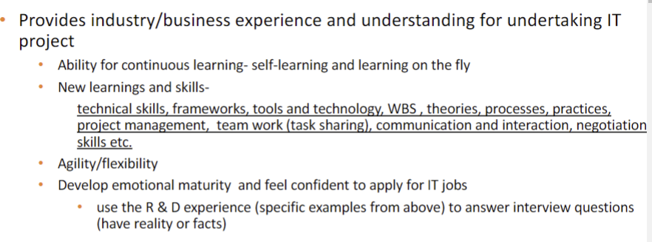

Average required hours: 12-15

Project deliverable-> functional **PROTOTYPE**

EOI can be used for worklog

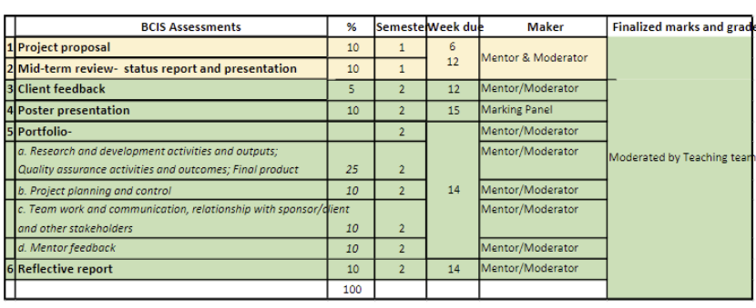

Offsite hours: 8-2pm either at client site or R&D lab (WZ701)

Groups revealed tomorrow

### Reflection

Because the groups are getting announced tomorrow and there was no offsite session, currently there isn’t any work towards it that can be done so the first priority would be to meet with everyone else. However, since the different templates are currently online, I could probably scan through the examples and familiarize myself with the documents my group needs for the proposal.

## Entry 2: Project Selection

My major(s): Software Development, Cybersecurity

|  |  |  |  |  |  |
| --- | --- | --- | --- | --- | --- |
| **Priority** | **Name** | **Specialization** | **Project goals** | **Requirements** | **Skills to be gained** |
| 1 | Twin Digital factory automation | Software dev/data science | Creating a simulation of factory automation process and creating online dashboard that interacts with sim in real time | N/A | Factory I/O  PLC programming  Data collection |
| 3 | PenTest.NZ | cybersecurity | Penetration testing processes  Test and evaluate current security programs  Publish outcome article on website  Develop own code | Linux  Travel to long bay  NDA  Python/networking | Python/networking |
| 2 | Cyber Forensics Ltd: Black Box Pen Testing 2 | cyber | Black box penetration testing | Knowledge in OSI layer 7 attacks | OS layout  Knowledge in the legislations/regulations in penetration testing in NZ |
| 4 | Game Development LiveOps Inspection Tool | Software dev | Event organizing/creating a shared calendar  Creating website | NDA | JSON programming  HTML/CSS |
| 5 | Sleep Data Project | Software dev | Data collection  Website to host data collection | None? | Data collection/ organization website building |

I chose Twin digital for my project even though I don’t major in data science, there is a lot to be learned with PLC programming, and the project seems to offer a wider range of skills I can learn than the other projects listed.

## Entry 3: Kick-off Team Meeting

### Notes

Meeting time: 6pm

Leader- Josh

Availabilities

No meeting after 7pm, use team offsite time for team meetings in the future <- add to team contract

Meet during weekend? (hopefully not)

Ask Matthew about client

### Reflection

The goal of the meeting was to familiarize ourselves with each other so we discussed our majors, hobbies etc. We elected the project leader, and also tried to schedule a time slot for daily standups or meetings. However, we had previously created an availability chart before online, and we saw that there were a lot of clashes. Due to the conflicting timetables and work schedules during the week, there would always be at least one person unavailable any time during the week so we might have to consider a meeting during offsite time given every Tuesday or the weekend if necessary. It was pleasantly surprising to see how everyone was willing to give some time up for the project during the weekend, and I was glad to be working with a team where everyone seemed pretty reliable.

## Entry 4: Kick off Mentor meeting

### Notes

Currently factory process is stage 3 industrialization

Stg 1: steam

Stg 2: electricity

Stg 3: automation

Stg 4: IoT

Goal is to move to IoT

Meeting notes

1st: 10.30am Tuesday

2nd: 3.30pm Friday

Client prefers mandarin over English

Final deliverable: website hopefully -> mobile version if we can

Use HTML/CSS/JavaScript

Team leader- Josh

Client coordinator- Yeran

Focus on finding a framework architecture type that suits us

More points if we don’t use SCRUM framework for SDLC

This week we should (according to Matthew):

Discuss project requirements

Go over assessment guidelines

### Reflection

During the meeting with Matthew, we were able to gain a little insight into the technical requirements for our project, which is mainly to create a simulation in which the factory, which is currently at stage 3 industrialization to stage 4 (IoT). We also set up the Github and Trello, and after Matthew’s suggestion, we agreed that we should have a meeting during weekends as well occasionally, as everyone was too busy during the weekday.

Additionally, we found out that the client is more proficient in Mandarin over English, which I think we should take into account when planning the meeting with the client. Although there might not be any problems, from personal experience I know how trying to communicate in a second language often causes confusion, especially during longer discussions. Since we have limited time with the client, I want to ensure that we spend that time efficiently communicating so that both we and the client come out satisfied, so it wouldn’t hurt too much to put in a little more effort into communication beforehand.

## Entry 5: Self-directed work

Worked with Yeran and Joshua to start identifying the tasks we need to complete and organizing the portfolio  
Created Trello board to organize/designate tasks

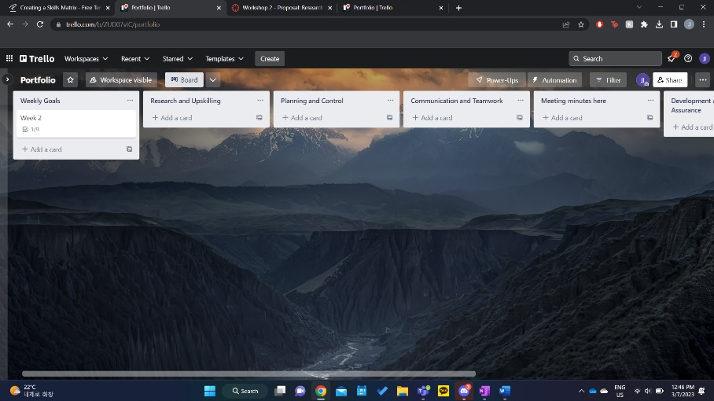

We decided that the layout of Trello would make it easier to navigate through tasks during the project. Trello allows for cards to be created for links to external sources such as github, can add checklists, discussions which made it easier for us to organize with everyone.

Yeran noted down the meeting minutes, and we decided it would be useful to upload the records onto trello so that everyone would be able to keep track of the discussions, goals and changes made in case of absentia as we found that our group had a lot of clashes.

Created the structure for a weekly schedule

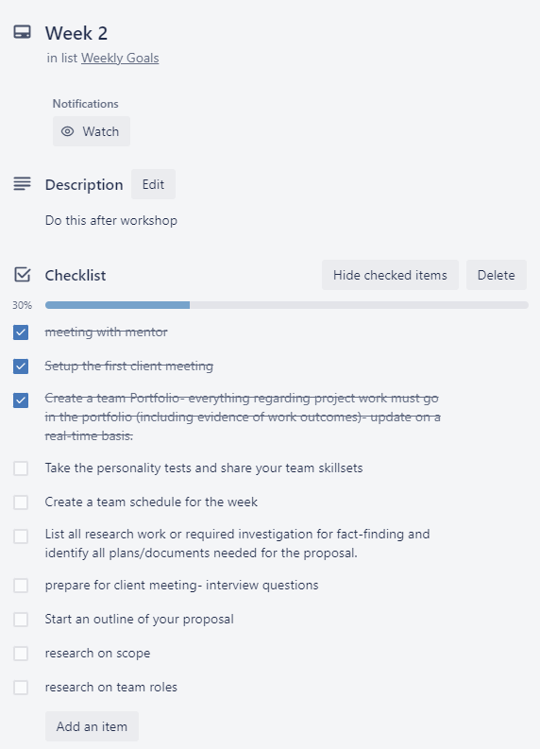 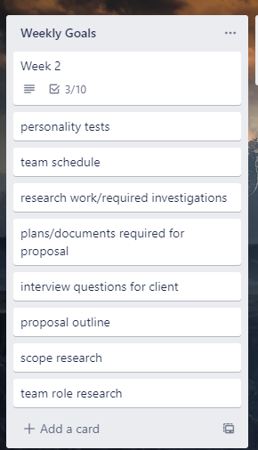

Created a checklist based on suggestions from the module and the lecture slides and created individual cards for each item on the list. These cards can be assigned to different members of the team which makes task delegating easier, and once the task is complete, the card can be deleted and the corresponding item on the checklist can be ticked off. This format can easily be repeated for later weeks as well, and is a good way to identify the work that needs to be completed every week.

## Entry 6: Week 2 Workshop

### Notes

Do not email staff on Thursday/Friday unless urgent

Respond to team emails in two hours

Team contract

Consequences of violations should also be clear

Don't put unrealistic goals on team contract

Proposal should be ready by the end of week 5

Decide presentation date/time with mentor in week 6

Mentor is in charge of booking the room for presentation

Part 1 has two assessments:

project proposal (10%)- due week 6

mid-term team review (10%)- due week 12

Team portfolio- (65%) this will be sued to provide evidence and has 5 assessment components

Mid-sem (10%): part 1

Mentor feedback (10%): part 2

Teamwork and communication (10%): part 2

Project planning and control (10%): part 2

Product development and quality assurance (25%): part 2

**Portfolio should also contain**

* Proposal
* Status report
* Poster
* Client feedback

Portfolio for final submission should be on OneDrive, but we can have working copies on github/trello

Don't share portfolio with client

**Proposal**

Should have reliable/achievable project plans and documents (can use ITPM templates)

Develop several project proposal plans -> included in the appendix

Project proposal requirements guide identifies various sections that NEEDS to be included in proposal

Upfront part of the proposal should be at MAX 10 pages, entire proposal should be 30-40 pages

**Client interview**

Gather background information on client

* Business goals/objectives
* Current operations including customers/clients/suppliers
* Current IT infrastructure that supports the business operations
* Current issues and challenges with business operation as a result of IT infrastructure limitations/issues or challenges
* Any business opportunities that exist; if they don’t have any issues like bullet point above, the organization might be looking into expanding their business which means we'll have to provide new solutions

The points above are called **business domain knowledge** and justifies the reason for undertaking the project (project rationale)

In proposal

* Identify project rationale
* Project objective- could be a product or solving a problem or take a business opportunity

Project scope- BASED ON PROJECT objective, required further investigation and negotiation with client to identify scope

* What level of requirements (func/non-func)
* Other client deliverables
  + Related to project
  + Related to client
* Success criteria (based from different stakeholder perspectives) client/us

WBS work breakdown structure- essentially project management structure

MAKE SURE WBS comes before project planning

Either follow client's wbs or create our own

Client meeting preparations

* Read and understand as much as you can about project domain
* Prepare questions that will help write proposal which in turn will help us plan the project
* Everyone should ask questions
* Designate meeting minutes taking/ask clarification questions/check answers
* Dress well, phone off
* Try and listen to the client to implicitly understand the actual project objective and requirements
* Establish with client regular meetings (day/time) and how they can support us during the project

Client tips

Ask specific questions such as

* Why this project is needed and problems/issues they want us to solve or any benefits they wish to receive
* How will they support the team- resources/documents/templates/training/method/practices
  + They educate us on the methodologies
* Point of contact
* Feedback and delivery cycles; project status reports
  + How should we ask you for feedback

After first meeting prepare a summary from team notes and send to client to ask them to confirm:

* Project objective
* High level requirements
* Important points in this project

**Writing proposal**

When writing proposal make sure we summarize all plans within 1 or 2 bullet points and the full documents are in our appendix

Good to mention risks for our project

3.3 Identify technical requirements to deliver products

Suggest alternate tools we could use and justify why we used a particular technical infrastructure

* Learning curve was too high
* Client provided the tool
* Client didn't want to pay for tool

After finding required skills every team member should provide their skill levels (high/middle/low)

Identify any missing skills

UPSKILLING

* Provide detailed upskilling schedule, no more than a week or two
* Don't need to go hard on upskilling now, focus more on technical skills in part 2 during the actual development of product

PM

Currently in first phase- design

We need to identify our PM method and justify why we're using this methodology

We bring in methods to come up with a methodology; scrum != agile

Identify operating structure: key phases and key tasks; after identifying these THEN we can create the project schedule

Also need to identify method practices based on method and methodology

Identifying the project methodology makes identifying team roles easy

Roles/tasks should be designated based on our majors and the skills we want to gain for future job opportunities

**In reflective report make sure you report other teammates contribution in relation to their roles and the responsibilities associated with them**

Daily standups once every week

Milestones used to establish how much work you want done for a task by what time (milestones can be found as assessment items)

**Leave detailed scheduling for part 2 during scheduling report at the end of semester (in appendix and not upfront)**

Uncover the type of client we have and identify any flaws in their thinking

Make sure we use the 4 folders to organize our portfolio structure

When there is a plan that can be in more than one folder, try separate the data so that we avoid having 2 identical documents in the same place

Make sure all documents are always updated; any changed made after feedback should be marked (e.g. schedule v2.2)

### Reflection

A lot of the segments required for the proposal can only be planned once we meet the client next week. However, this gives us more time to preparing so that we are able to use our time efficiently when we are able to interview the client, as well as gain insight on how to alternately spend time as well. According to the lecture, some of those would be:

* Researching the client and our company/preparing questions
* Researching the scope
* Researching the different types of WBS
* Creating a template for the project proposal
* Identifying the list of plans we need for the proposal

## Entry 7: Self-directed work

Created a skills matrix

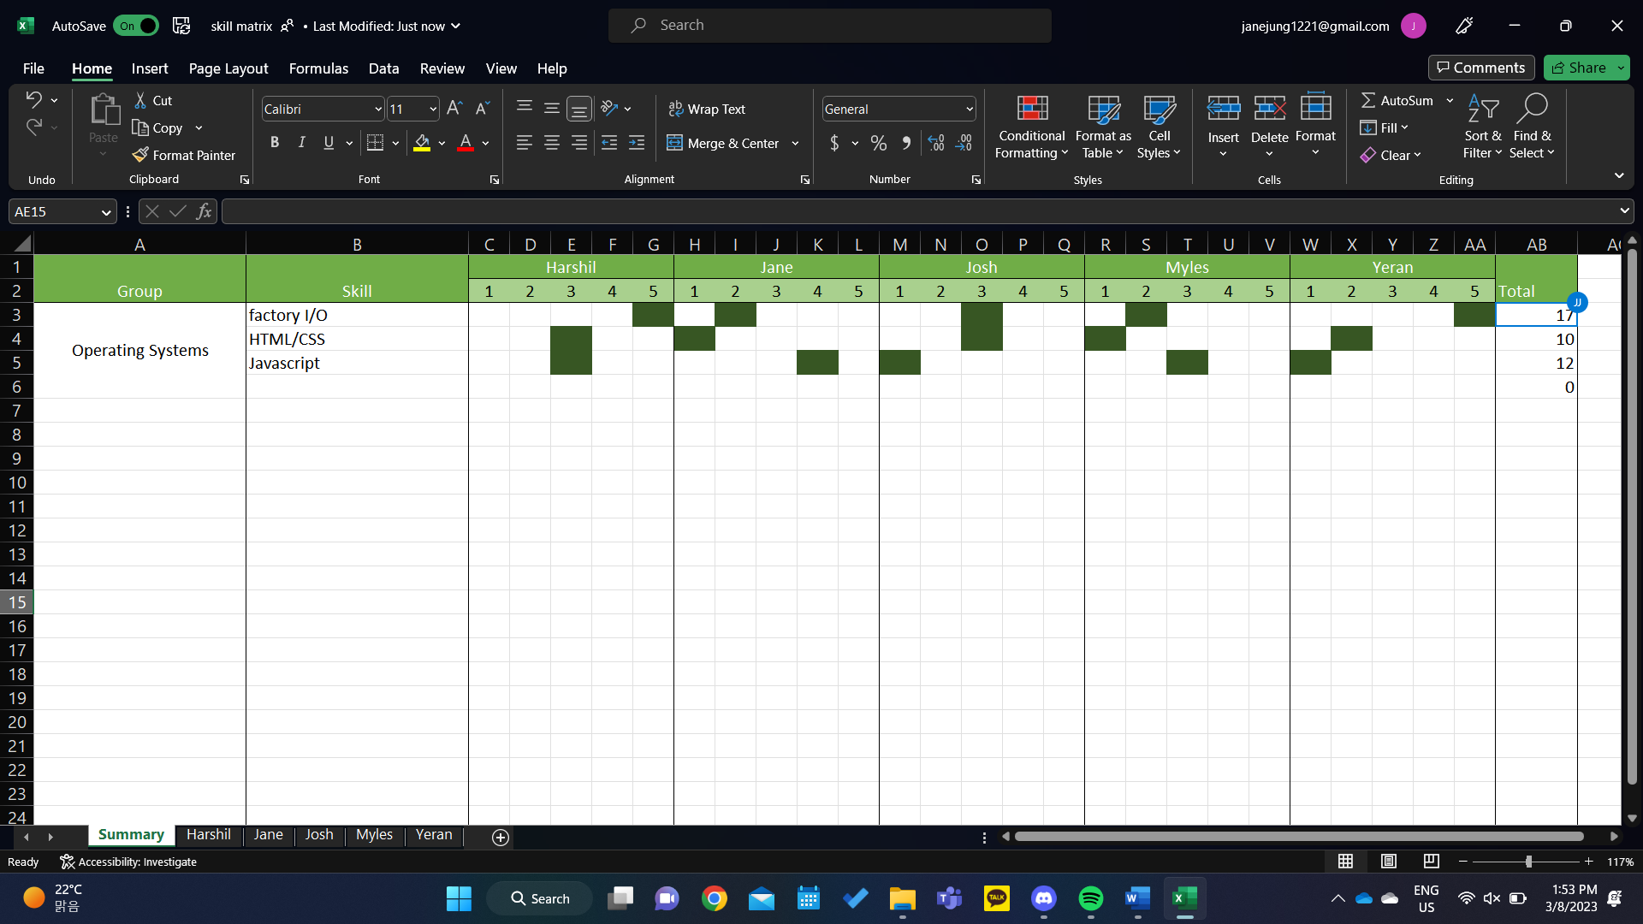

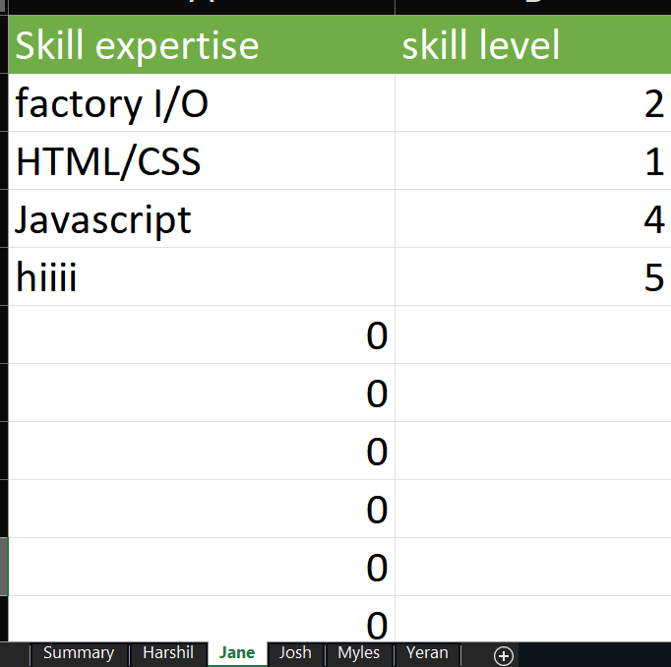Because we have 5 members, I thought it would be suitable to create a separate page for everyone, where the values they enter would automatically be updated in the summary page shown above. This way we are able to measure the expertise of a skill for the team as a group with the total score and also quickly see everyone’s strengths and weaknesses. Once we meet up with the client, we can add more skills based from the meeting to identify key skills required to meet the functional/non-functional standards of this project.

## Entry 8: Week 3 Mentor Meeting

### Notes

Things we can do without client

* Team contract
* Project charter
* Stakeholder register
* Stakeholder management register
* Personality tests
* Communication plan

**Need to create proposal template**

Only proposal needs version control

Ask tommy whether we need to have version control

After meeting create UI prototype of the interface (most likely web but which type of device)

We only have to simulate the conveyor belt the machines don't have to be recreated with detail

Purpose of the project is to create an interface that controls machines

Add color to skill matrix

SDLC- use any agile approach; waterfall/Kanban for method? (Probably better with Kanban)

Our stakeholders

Us

Matthew

Client

Ramesh/Jacqui/Tony

Current issues

We can't speak mandarin

Matthew will be translating for us

We can send a simple clarification email afterwards

Our timetables are bad

Meeting during the weekend

To do:

**Project proposal template**

Add color to skill matrix

Decide on SDLC

Set project budget

Finish all the plans that don't require the client

### Reflection

During the meeting, our mentor Matthew advised us to start on at least our template for our final proposal as he was concerned that we were falling behind due to the clashing timetables between our team members which made it difficult for us to arrange a stable meeting time for each week. So far, we tried to keep up with the workload by communicating consistently through discord, but we agreed that the lack of a proper meeting and opportunity for proper discussions was significantly impacting the group’s process in the project. We consequently decided that we would additionally have online meetings on Saturday so that we can get on track for the proposal.

We also discovered that the language barrier between us and the client was going to be a bigger issue than we initially expected as Matthew predicted that our client probably wouldn’t be able to understand any conversations that involved technical terms. Matthew will be coming with us to the meeting and translating for us, but we will have to prepare well to avoid miscommunications and spend our time wisely with the client, especially as we found out that we were not going to be able to see him regularly.

## Entry 9: Team meeting

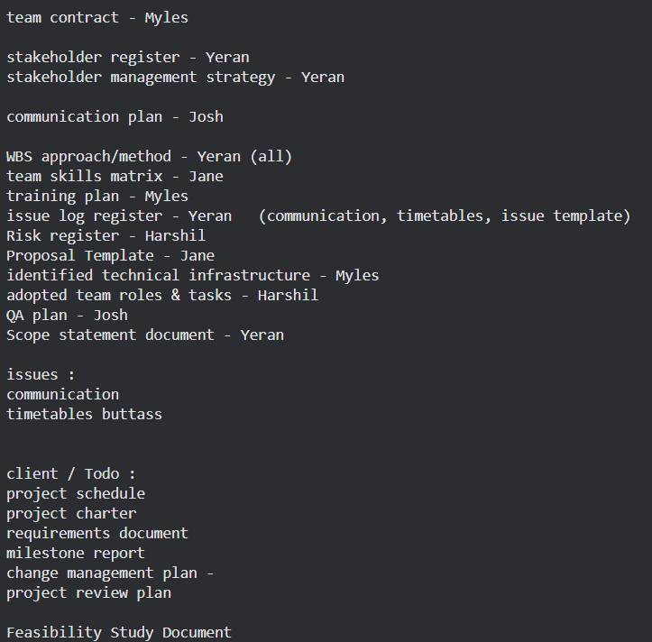After the meeting, the team had a discussion to organize our goals for the week and do some work together. Aside from creating the template of the proposal, Matthew also suggested that we start completing some of the plans required for the final proposal. We decided that we would try and finish all the plans that wouldn’t require information from the task and so designated different tasks to members of the team, as shown. We also decided that once a task was completed by a member, they should ping the rest of the team so that we could all review the document together to maintain continuity between everyone and prevent potential isolation of knowledge between the team.

One of Matthew’s feedback was that the skill matrix was looking a little to monochrome and made distinguishing the team’s skill levels a little too difficult as every cell was colored the same. Taking that into account, I changed the formatting of the spreadsheet so that there was a color scale to make identifying skill levels easier.

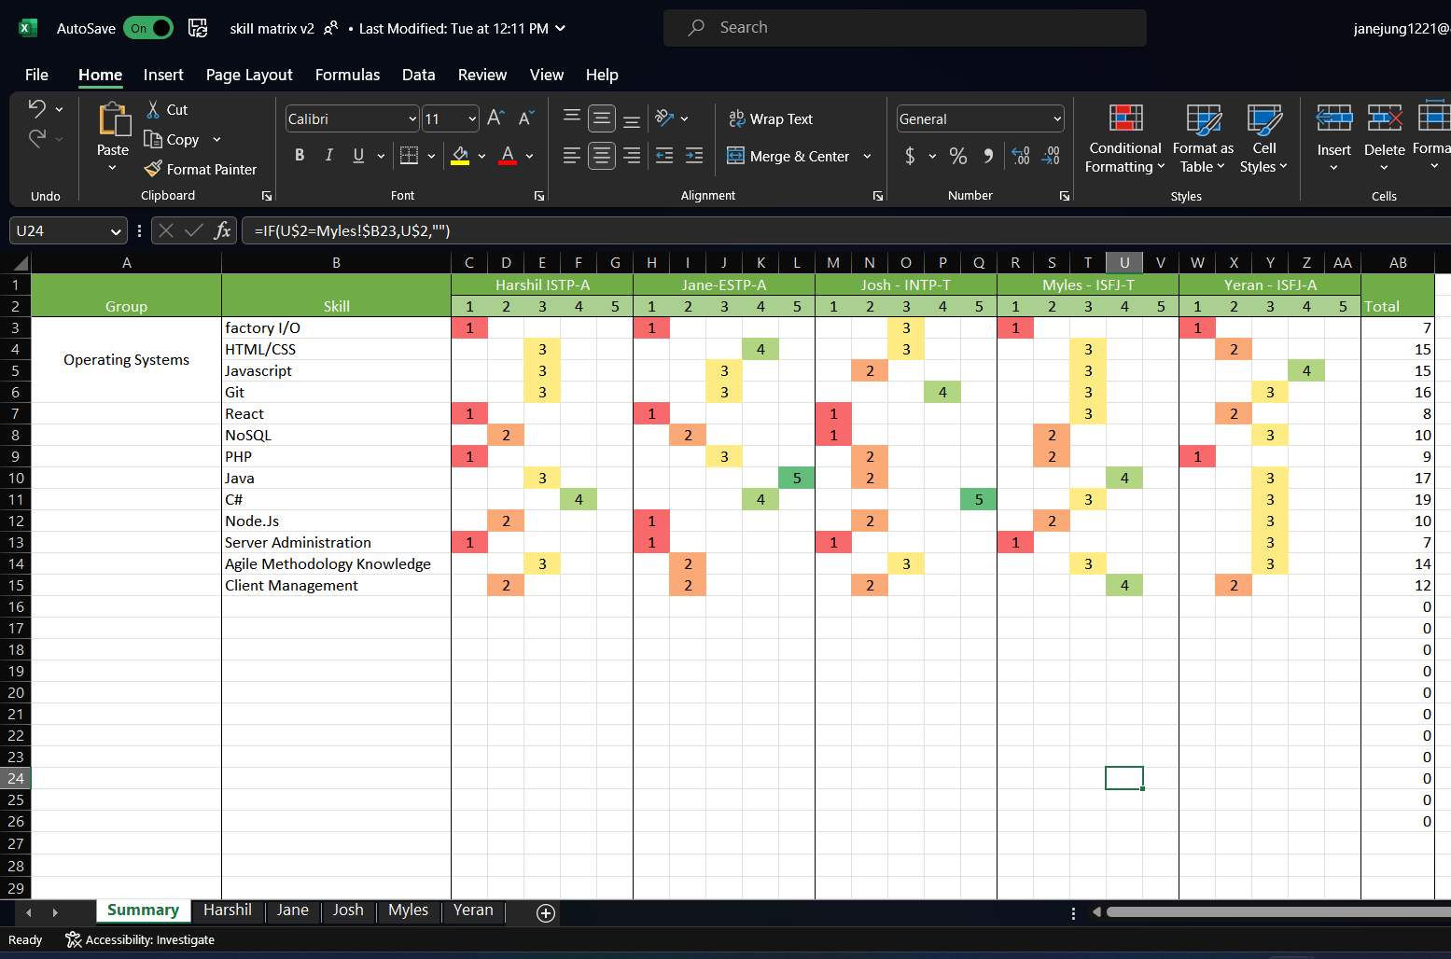

Personality test??

## Entry 10: Week 3 Workshop

### Notes

First assessment needs to be completed by week 6

MENTOR must book room

Team presentation (sick people can join online)

In case mentor/moderator is sick, lecturers can step in

PROPOSAL NEEDS TO BE EMAILED TO MENTOR/MOD BY END OF WEEK 5

Proposal must show project is necessary/feasible/manageable

Requires Project management methodology to show project is manageable and a project objective can be delivered despite any uncertainties

PMI - Project Management Institute

Requires PM methodology

Identifies project tasks/deliverables

Break down project into tasks and subtasks so that the work can be planned, scheduled and executed within time

Phases- group specific tasks

Phases and tasks provide wbs

WBS-> breaks down a task into several INDEPENDENT subtasks

PM methodology for R&D

Planning phase- identify key tasks of planning phase

* Identify and break them into smaller subtasks
* Think about quality assurance procedure

Project phase- phase after the planning phase; the outcome from the planning phase (proposal) will feed into next phase

Any IT project must have in order an analysis, design, implementation and deployment phase.

How do we identify these phases in our project? Do we create or adopt a tested method and its phases?

Some examples for methods in software dev- SDLC/RUP/SCRUM

Methods are a combination of

* Phases, practices, task/procedures- specified WAY to carry out activity
* Instructions- detailed directions on how to perform task
* Rules- prescribed guide for conduct/action
* Plans
* Tools
* Roles

PM methodology = PMI (PLANNING) + the adopted method (analysis, design, implementation, deployment) + adopted method IDEOLOGY

PM methodology is a **set of phases and practices, driven by a philosophy (e.g. agile)**

For our phases of the project and therefore PM methodology

Phase 1- Planning (proposal)

Phase 1.5- Upskilling

Phase 2- analysis, Phase 3- design etc

**NOTE:** Any upskilling for the project MUST be included in the PM methodology. Learning should be included as an independent phase and rearrange + label phases to give PM methodology. <= THIS CAN BE OUR WBS

Include WBS upfront in the proposal, and use it to schedule the entire project.

WBS breaks down project

* Gives project phases
* Breaks work into independent tasks in a phase
* Enables planning and MC project schedules/changes/resources
* Provides deliverable-oriented work

Additional things that can be helped by WBS

* Practices, tools, techniques to be carried out and when
* Communication, interaction and decision making practices
* Project roles and responsibilities
* Learning techniques and practices
* Reflection and feedback practices

PM methodology will shape team's contract and teamwork

Team contract must be revised to incorporate how the team will work based on the practices of the chosen methods including the expected behavior

### Reflection

During our meetings with Matthew, we established that we need to create a prototype interface that can show and control a factory line in a simulation. I was worried whether we could complete this project, as it felt like there was such a big project we had to complete in such a short time especially as our team was already falling behind. However, going through the project methodology in the workshop helped me identifying the key tasks in the project and breaking the workload into smaller much manageable tasks. For our project there are two large requirements: creating a simulation of the factory and the interface that can connect and control the simulation. A hypothetical way to break down the interface would be to create a webpage with a dashboard UI first, creating functions that would only affect webpage processes (e.g., menu button, navigating to different sections), creating the functions that control the factory. These tasks can be tested and developed individually and can easily be built up to create the final outcome. Using this strategy to view the project reduced the mental pressure I had previously and helped me identify how we could use some of these methods in our planning session as well.

Although there wasn't an official method decided by our team yet, I noticed that we were already using some of the PM methodologies while working. We had broken the proposal into the tasks used to create it and designated them to each other, so everyone had a manageable workload. We had rules for when tasks were completed mentioned earlier such as if a member finishes a document, they will ping the team for verification before marking the document as completed, and once a task was completed, they would be ticked off the Trello boards so that we could keep track of our progress. These rules we set up will later help us establish our project management method which we can use to steadily progress onwards later in the project.

I definitely think it’s important that we decide on a methodology soon, especially since our team’s timetables prevent us from meeting regularly. Having a set method will increase our productivity as we start getting used to a continuous pattern in our workflow and allow us to deliver a higher quality outcome.

## Entry 11: Self-directed work

After updating the worklog book, I started planning the layout of the proposal using the guide provided to us available on canvas. Because we don’t yet have any plans completed, I only noted down where each plan should be discussed under the headings to make the navigation easier.

I also started filling out the issue log with issues we discussed before during meetings, and will be updating this regularly throughout the project.

|  |  |
| --- | --- |
|  |  |

## Entry 12: Client Meeting

### Notes

Questions

* + Could we be allowed to record the meeting if necessary?  - Y
  + What are the key metrics you would like the dashboard to track?
  + What types of devices would you like the dashboard to be accessible on - Desktop, doesn't matter whether we use website or app
  + What information would you like to get from the dashboard
  + Are there any technical infrastructure you would like to provide - source code for the machines?
  + Are there any tools you would like us to use when developing the product - none
  + What are you currently using to manage your PLCs? - on site PC on each machine that uses a connected monitor
  + Can you tell us more about what prompted you to have a PLC interface? Why you want this?
  + Is there anything you can tell us about what you envision for the board? Anything about how you picture it looking or working?
  + Do u guys have some machines models on factory io we can use - No
  + UI design?  - copy current interface on machines, add start/stop
  + Are we allowed to use Github to create copies of our documents during this project? - Yes

Machine:

Conveyor belt

Chute

Shaping cup/cup shaper

Minimum requirement: connection between machine and interface

Would be good if dashboard could control multiple machines

Start/stop button

Source code provided

Start upskilling on factory io asap

Send client copy of proposal once finished

Interface could also be in Mandarin?

|  |  |
| --- | --- |
|  |  |
| Interface used to control machines | Different ports all connected to the computer, which is attached to the controlled monitor. |

### Reflection

We met with Daniel Li (founder of Jadcup), and took a tour around the factory to see how the machines worked in person. We saw that each machine was being run individually with its own PC and an attached monitor which was used to control them. Afterwards, we spent some time asking the client questions for some further clarification (with Matthew translating). There weren’t any particular restrictions set by the client, he was happy for us to use whatever tools we wanted as we developed the project. Talking to the client established our base goal, to connect the machines to an online database that would allow them to be controlled remotely on a desktop computer either as an app or web page. Looking at the production process made us realize how much work we would need to do and how many skills we required to complete them, and so our team decided that we should start upskilling immediately to be able to produce the outcome in time.

## Entry 13: Team meeting (online)

### Notes

### Reflection

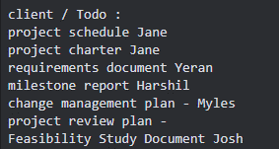We had a meeting to update each other on the progress we each made for the plans we were assigned to and discuss any thoughts or questions we had for the proposal/project. Everyone had been making steady progress on the plans they were assigned to. We designated the rest of the plans that we wanted information from the client before completing, as shown, and we set a goal to complete all the plans by next Tuesday to give us more time to write the proposal and to upskill for the development of the project.

We also had a discussion of our WBS and our project methodologies, as we knew that it was critical that we find a steady working method before we move onto the development phase of the project. We had already decided on the method we would use- Kanban, which was a method all of us were familiar with thanks to SDP. However, I thought that we should also concrete the roles we all had within the project as well as we only had the project leader and client liaison decided. Since our project’s outcome splits into many different fields, I suggested that we assign two people who would be responsible for the development of the different sections we need for the project, the leader and the backup. The leader would be somewhat confident in the skills required for the section, and the backup role would be designated to someone who might not have skills but was interested in learning more in that area for future career opportunities. (You can see the different sections we came up with in the notes section).

Finally, we had a brief conversation about our previous meeting with Matthew and all of us agreed that we could have spent the time better. We decided that we should meet 30 minutes earlier the next mentor meeting so we can spend some time organizing what we want to show Matthew for feedback, and questions that we want to ask him so we don’t waste time during the meeting itself.

## Entry 14: Self-directed work

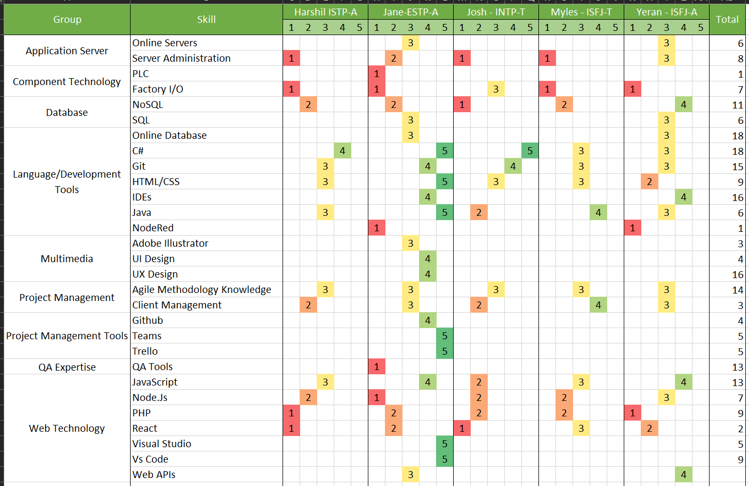

I updated the skill matrix to add more skills that we thought would be relevant and sorted them into different categories. Additionally, I also started working on a project schedule using Microsoft Project. In week 2, the paper leaders mentioned that the schedule at the moment didn’t have to be too accurate on the dates, and that we were allowed to update them later in the semester. I used the WBS created by Yeran as a template for the general structure of how the project should look and used the dates on canvas to create some milestones representing deadlines on the chart. Finally, I also wrote up a project charter for the team, which I plan to add to the proposal after confirmation with Matthew.

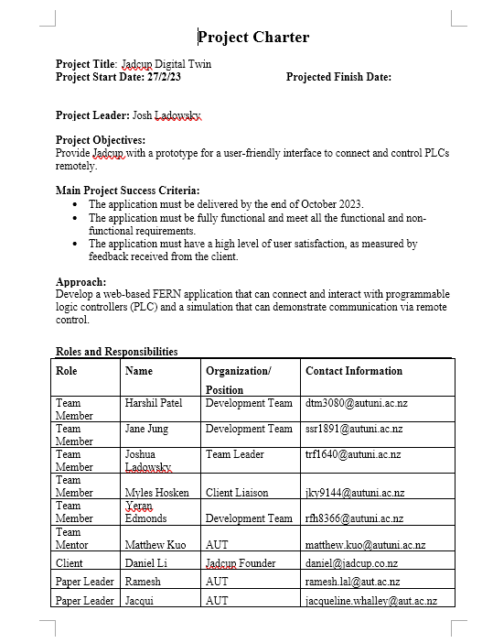

## Entry 15: Self-directed work

I started filling in the proposal with completed plans so I that I could locate any sections where I had questions to ask Matthew during the mentor meeting tomorrow. I filled in sections 4, 5 and 6 and added the relevant plans in the appendix as well.

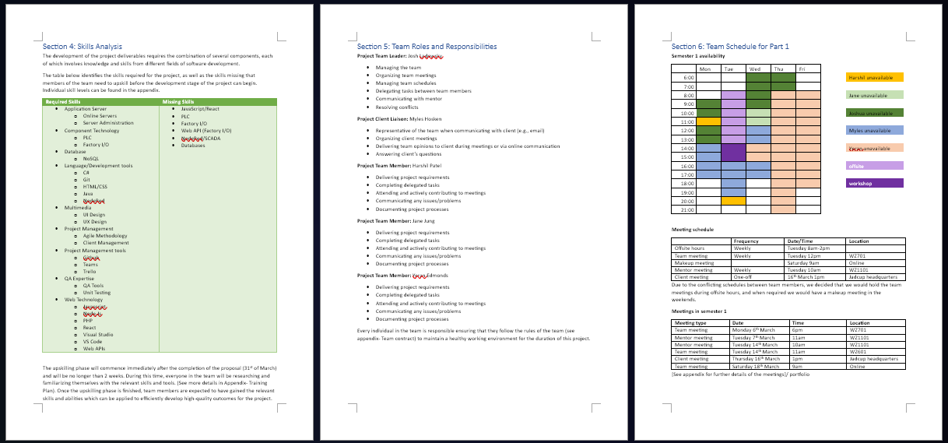For the other sections, I felt like the relevant plans were missing information or needed to be rewritten, so I went through some of the documents the team had uploaded so far and added comments/notes on what could be improved.

|  |  |
| --- | --- |
|  |  |

I also went through the entire document and wrote the questions down to ask Matthew, as I knew we were behind schedule and wanted to use the chance we had to clarify as many sections as possible so that the team could start filling in all the sections together immediately after the meeting. The questions were:

* Difference between Terms of Reference and project rationale
* Do we need stakeholders in rationale
* Do the skills have to be displayed in order of relevance to our degree
* Project charter
  + Check whether what we have enough already
  + Do we need stakeholder signature
  + Who are the stakeholders
* Do we need to make team roles more specific (e.g. this member is responsible for web app dev)
* M/C in section 8- is this for just risk/issues or the entire project (change management?)
* Do we put whole docs in appendix
* Do we include software cost if we got license
* How detailed does the project schedule have to be

## Entry 16: Team meeting

The team had a meeting beforehand to discuss what questions we wanted to ask Matthew or what we wanted him to review. We additionally tried to discuss amongst ourselves the questions written above.

## Entry 17: Week 4 Mentor meeting

### Notes

* Difference between Terms of Reference and project rationale

Business goals stated in tor, explained further in rationale

Add stakeholders to tor

Specify project purpose tor

Explain in tor what is currently lacking in Jadcup’s production method

* Do we need stakeholders in rationale

yes

* Do the skills have to be displayed in order of relevance to our degree

no

* Project charter
  + Check whether what we have enough already

Make goals more specific/ change success criteria

* + Do we need stakeholder signature

no

* + Who are the stakeholders

Add tony/weihua

* Do we need to make team roles more specific (e.g. this member is responsible for web app dev)

No, but change names to match kandan methodology

* M/C in section 8- is this for just risk/issues or the entire project (change management?)

Entire project, add change application form as well

* Do we put whole docs in appendix

ye

* Do we include software cost if we got license

ye

* How detailed does the project schedule have to be

Dates are less important, make sure it shows team’s progression

Additional changes

* Detailed upskilling schedule required
* Adjust wbs for agile
* Draft for interface design
* Meeting minutes can be a link to portfolio
* User stories instead of days spent
* Milestone report should include holidays, use milestone for project schedule

### Reflection

We presented the current progress we made to Matthew, and we also asked the questions we had. Afterwards, Matthew suggested that we could adjust our proposal to replace the standard WBS with user stories instead, since we’re using agile/kanban methods which doesn’t give specific dates, and instead use milestones to make a rough estimate of deadlines between each cycle/phase. Matthew also requested us to create a draft by Friday lunchtime that he could read so that we have plenty of time to use any reviews he gave us to further develop our final proposal

## Entry 18: Team meeting

Immediately after the mentor meeting, the team got together to delegate sections of the proposals between members to finish before Friday as well as start creating some user stories for the WBS.

|  |  |
| --- | --- |
|  | * As a small business user, I want to be able to freely control the amount the cups I order (e.g specific number) * As a factory worker, I want to be able to remotely monitor the production process using a web application * As a factory worker, I want to be able to remotely control the production process using a web application * As factory owner, I want my production process to improve to industry level 4 * As a factory owner I would like the process for connecting a new PLC to the web application to be simple so that anyone can learn and use it quickly * As a client, I want access to the controls restricted * As a client, I would like to see a demonstration the potential application of the web app in a simulation to reduce damage * As a factory worker, I want the values that are displayed on the web application to be saved if they were modified to reduce time spent on customization |

## Entry 19: Week 4 Workshop

### Notes

Team culture/conflicts

Team culture for R&D projects

Resolving conflicts

PM methodology- defines project tasks including how tasks will be undertaken

Identifies WBS/phases for project in logical order

Identifies phase deliverables, deliverables for key stakeholders (e.g. skills we gain)

Must provide visibility in project, makes progress clear to us/client/mods

Must be able to M/C tasks and status report can be produced anytime

Should be able to provide the tasks the team did every week if asked

HOW tasks will be done- identify practices, techniques, tools etc, which will go w PM methodology. **How does the team apply those practices/techniques/tools to complete tasks?**

Completed tasks/outputs including learnings must be in worklog book and team portfolio

Write about our experience during task

Don’t do any work without following PM methodology

Project phases are based on planning, analysis, design, implementation and deployment tasks

First phase is always planning (planning = proposal)

PM methodology will be based om PML (plan phase) + adopted METHOD (FOR OTHER PHASES) + METHOD PHILOSOPHY.

Learning phase can also be included

Whatever method we adopt, we must also identify the method philosophy behind it as well.

Team culture- how team members work together towards a common goal and how they will treat each other during project, teams must communicate to establish how they will build their cultures, instead of assuming everyone will know already

Teams must develop its culture based on shared values, beliefs, attitudes and behaviors.

Values- worthy ideas to adopt for successful project

* Collective attendance for all R&D project ceremonies (workshops, meetings etc)
* Team diversity- respecting all team members
* Working closely with team members, mentors, key stakeholders
* Open discussions, face-to-face interaction/communication, feedback, individual contribution
* Continuous learning, upskilling/learning from one another, coaching/mentoring each other

Beliefs- assumptions/convictions hold to be true based on past experiences

* Collective planning/scheduling
* Collective effort/task sharing
* Adopt short work cycles for entire project
* Regular M/C work to measure progress and provide project visibility
* Deliver value for the client- regular client meetings and feedbacks, status updates, and continuous and regular delivery of artefacts
* Maintain a consistent work pace- between 12-15 hours per week throughout project until completion

Attitude (values + beliefs) - what team can do and will do

* Plan, commit and deliver for day, week, short cycles etc
* Learn new technical and non-technical skills on the fly to deliver work
* Deliver bug-free and valuable features (high-quality)
* Provide project status in a real time

Behaviors = result of last 3 - trust, conflict resolution, commitment, accountability & result driven

* Trust- transparent and honest with each other, can share any info
* Conflict resolution- having constructive and productive debate ideas and possible options on issues
* Commitment- fully buy-in and commitment to plans and decisions
* Accountability- having clear plan of action and willing to be accountable
* Result-driven- produce work you have planned and committed. It is ok if work produced than less than plan, as long as there is evidence that you have put in the effort

Make sure we write out team culture explicitly- otherwise the team will have a dysfunctional approach

Ideal team culture- the culture that brings the best project outcome for all (3 key) stakeholders

Team culture can still be established without explicit description, but it may be a culture that has:

* Lack of commitment
* Lack of motivation for consistent work
* Lack of ability for delivering objectives
* Lack of visibility
* Failure to apply established practices
* Failure to keep record of progress
* Lack of quality

Culture for self-organizing team

* Team collectively plans/manages work and associated responsibilities
* Not dependent/micromanaged
* Individuals take initiatives
* Establishes working relationship w all stakeholders
* Respects and reusts each other and stakeholders
* Colocated to have solid teamwork and collab
* Team member communicate to work effectively
* Attitude for learning/upskilling on the flu
* Coach/mentor each other
* Continuously focuses on improvement and growth
* Collectively take ownership

Storming phase

* Normal tension, struggle and sometimes arguments occur
* Can lower motivation if uncontrolled
* Some teams will never develop past this stage
* However disagreements within the team can make members stronger and able to work more effectively as a team
* If team members are able to transition from storming phase to a team focus and resolve differences, members will be able to participate w one another more comfortably

Team building tips/ideas

* Social time for team building
* Stick together as a team
* Understand yourself/others
* Define clear team roles
* Team learning, upskilling, coaching and mentoring
* Set ground rules for expected behavior
* Continuous reflection and feedback to get better- be objective/clear avoid blame game
* Establish clear conflict resolution process

What is conflict

* Difference of opinion with strong feelings or ego attached
* Shows up in a range of ways/behaviors such as disagreements, opposed views, confusion, uncomfortable feelings
* Can result in positive and negative outcomes

Positive outcomes

* Consideration of a broader range of ideas, resulting in a better, stronger idea
* Surface assumptions that may be inaccurate
* Increased participation and creativity
* Clarification of individual views that build learning
* More buy-in and ownership of the outcomes

Negative outcomes

* Increased stress/anxiety amongst individuals; decreases productivity and satisfaction
* Feelings of defeat and demeaning; lower morale and may increase turnover
* Climate of mistrust; hinders teamwork and cooperation required for work

Prevention/ early intervention

* Create safe work environment
* Be on the lookout and attend conflict straight away
* Trust groups collective intelligence- groups can work through any conflict if committed
* Monitor group constantly

* Conflict resolution process to address when  
  someone isnt attending meetings
* Is delivering poor quality work
* Isn't reviewing work with care
* Someone's personality dominates and silences others
* Strong opposing views surface
* Someone isn't pulling their weight
* The aspired team result isn't reached
* Falling behind schedule
* See low energy or team members disengaging

Avoid blaming/scapegoating

* Blaming an individual/group for things going wrong
* Avoids responsibility of resolving conflict

To-do this week

* Book proposal presentation
* Complete proposal before end of week 5
* QA before emailing proposal
* Make sure everything is covered as stated in proposal guideline

## Entry 20: Self-directed work

I started modifying the proposal as the team added entries after the team meeting, modifying orientations to fit documents that were in landscape orientation, sorting through information and tagging in the appendix and unifying the overall style.

I also started working to complete the sections that were delegated to me using the feedback given during the mentor meeting yesterday.

**Upskilling schedule**

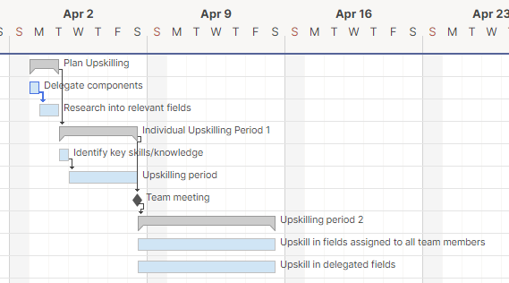We confirmed with Matthew that in addition to our training plan, we also needed to include a detailed schedule we intend to adhere to during our upskilling stage. I used an online project scheduling platform called smartsheet to create a mini gantt chart that would outline our upskilling schedule. Because we have a lot of different skills, we had decided that we would delegate the different components between the members, which means that the upskilling field for individuals is narrowed and reduces pressure on everyone’s workload.

**Project schedule (Gantt chart)**

I also started on creating a project schedule using the WBS we had previously created as well as the milestone report written by my teammates, although the WBS was used loosely due to the fact that we had Waterfall in mind as the project. The gantt chart I made before was also closer to the waterfall structure, where all the tasks were planned to be completed in a chronological order of progression and required the deadlines/times spent working set before the development process started. Our team wanted to use an AGILE framework for our project, which uses sprint cycles to create releases of multiple deliverables at once and consistently updates them throughout the iteration cycles. Additionally, we also wanted to take the Kanban approach, which divides requirements into smaller tasks, then gradually completed by constantly cycling between development and testing stages until everyone is satisfied. Taking that into account, I tried to adjust the structure of the gantt chart to better represent the sprint cycle approach, with key phases identified similarly to before, but with more leeway so that dynamic adjustments would be easier for what user stories would be developed, how much work we intended to complete in that iteration (points), deadlines etc. 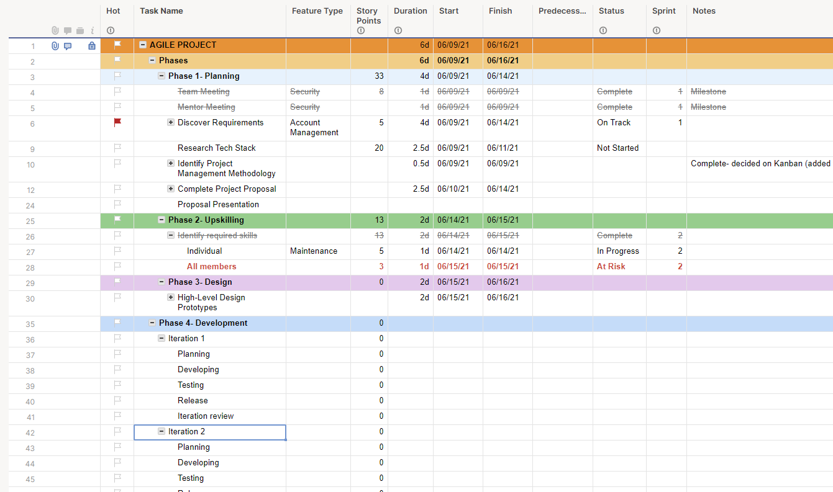

Trying to create a gantt chart was a little difficult with AGILE as gantt charts are closer to a traditional waterfall approach and I had to try a lot of different formats, but the team felt that the ability to mark milestones and how it displays subtasks would give us insight on how we could schedule around deadlines, holidays, what large tasks can be broken down further etc. Because the dates aren’t too important at this stage, I focused on the structure of the chart but I plan to add in the milestones soon as an example and once the team finishes modifying the WBS, I can add more details into the schedule.

## Entry 21: Self-directed work

I sent Matthew and email to ask about the gantt chart as I wanted to make sure that the format I was using was concise and appropriate to our team’s decided project methodology, and used the feedback from Matthew to moderate the structure.

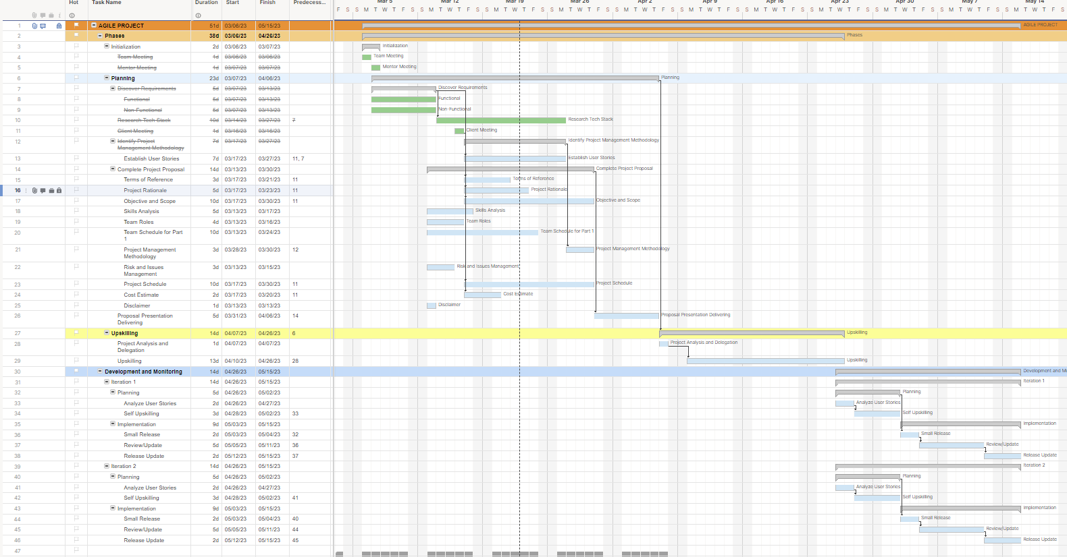

I merged the design with the development and monitoring phase and divided the iterations into their own planning and development stage which can have time allocated to it dynamically depending on the condition of the team members. After setting a base structure, I added the milestones and the estimated dates of the tasks/requirements using the milestone report prepared by Harshil, and highlighted the holiday periods that could be shown in the timeline. I also moved both the upskilling schedule and the project schedule to Microsoft project, as it allows more detail to be added to the schedules and because I found out that I was using Smartsheet with a free trial and didn’t want to lose the files after the trial period was over.

Completed project schedule:

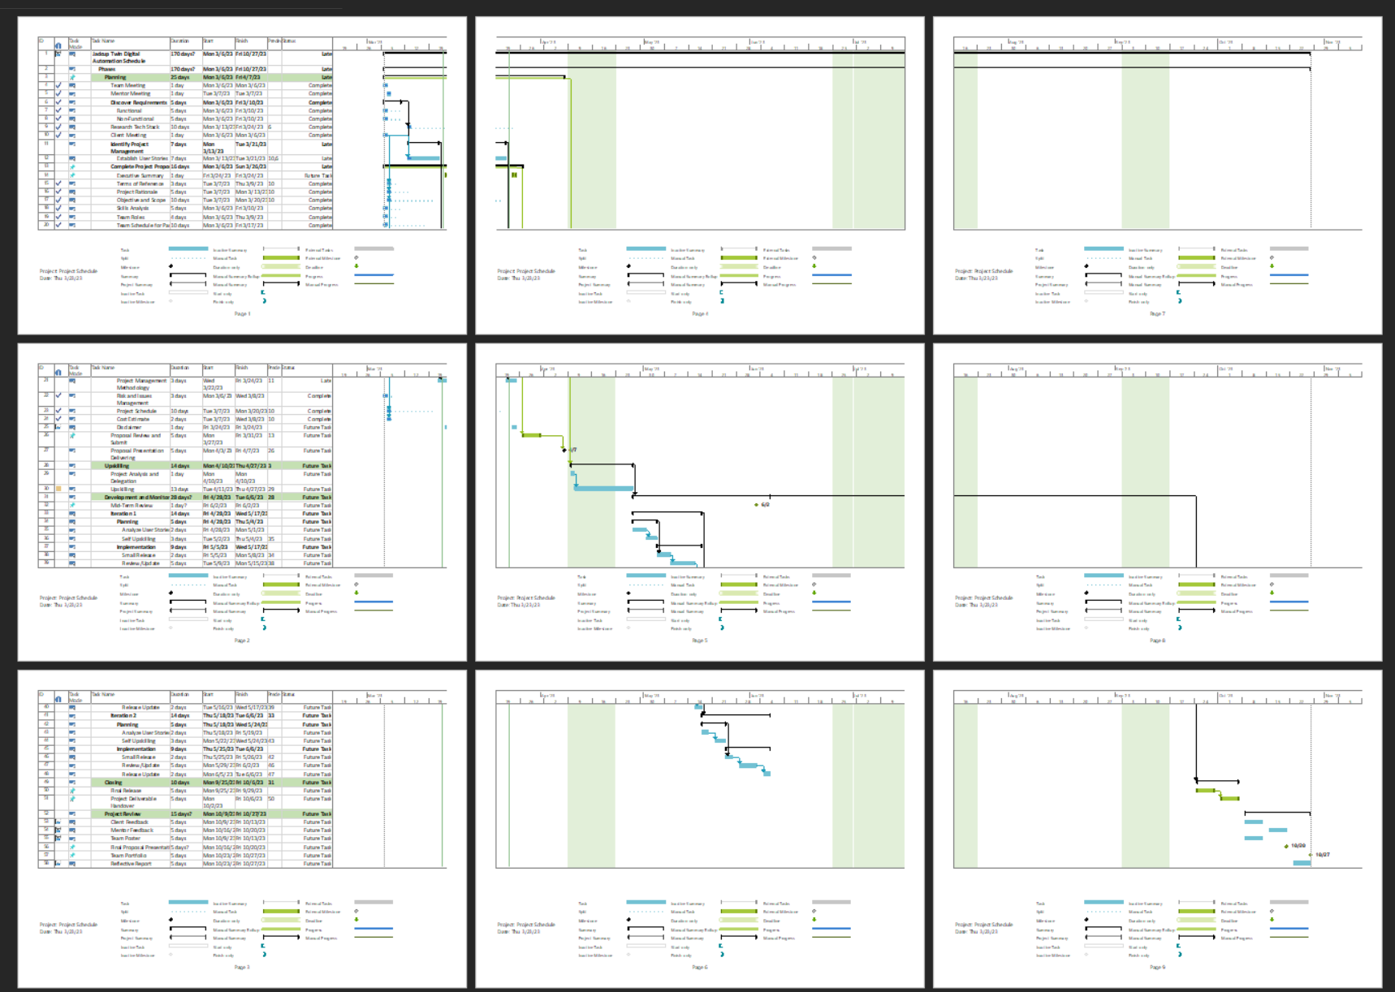

Completed upskilling schedule:

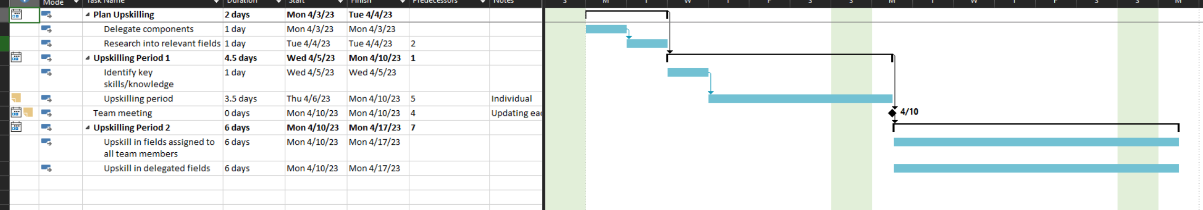

After completing the charts, I added both of them well as the milestone report to the appendix of the proposal and wrote a summary of the project schedule as well.

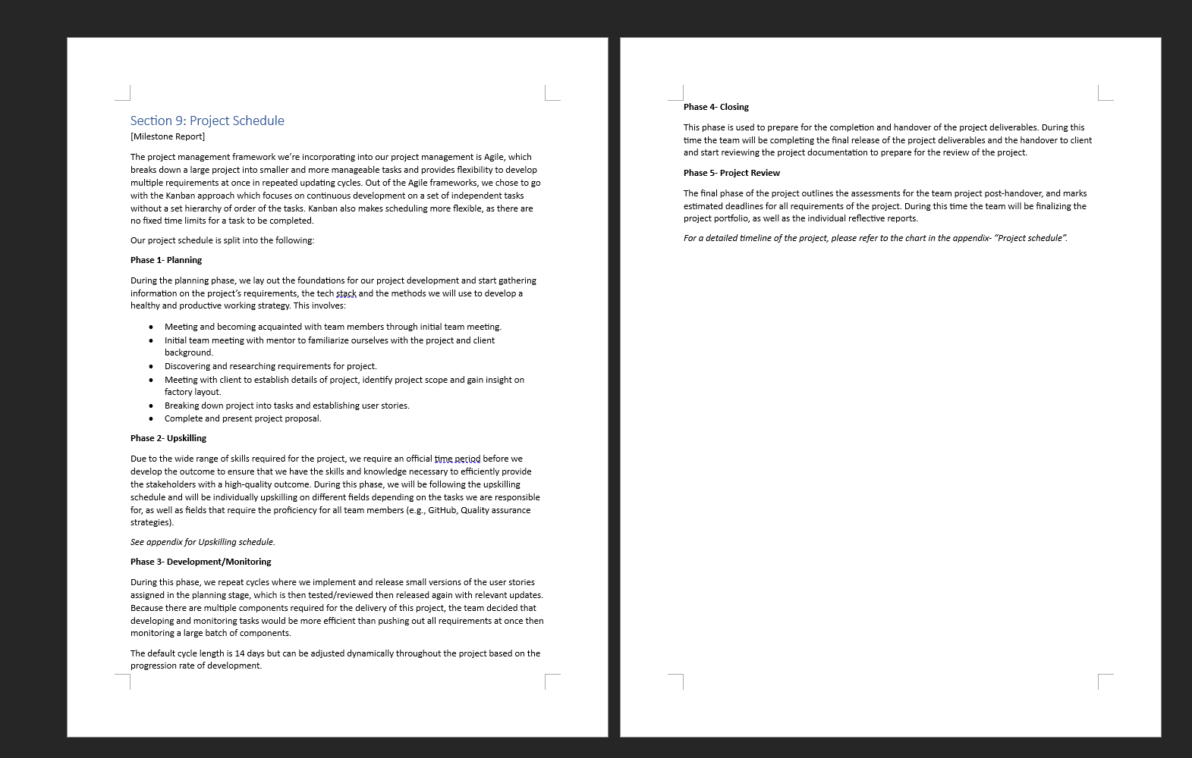

I also added the WBS that the team modified following Matthew’s feedback.

## Entry 22: Team Meeting (online)

We had an online meeting from 9am-12pm to work together on the proposal following Matthew’s review the proposal draft submission.

## Entry 23: Self-directed work

Matthew gave us a lot of feedback on our proposal, so I took over the project management section which was originally assigned to a different teammate as he had a lot of work assigned in other sections as well. I took the feedback given by Matthew to explain the rationale behind choosing kanban over other project management methods, and started explaining the work breakdown structure. Because I’m a little unsure on the key tasks criteria I plan to ask Matthew tomorrow during the mentor meeting before proceeding on this section.

## Entry 24: Week 5 Mentor Meeting

Meeting notes:

We went through the whole proposal with Matthew during the meeting, and he gave us a final review before our submission. Yeran and I took notes of the meeting session, and we created a to-do list for the team to complete

## Entry 25: Self-directed work

I updated the project methodology section based on the reviews shown earlier and added comparisons between Kanban and Lean. I also described more in-depth how Kanban is incorporated into our project development methods and how we’re using Trello to accomplish the Kanban approach.

|  |  |
| --- | --- |
|  |  |

I sent Matthew an email after to ask if he could check the work and whether it was more in focus to our team, and to also ask questions to clarify some more assessment requirements.

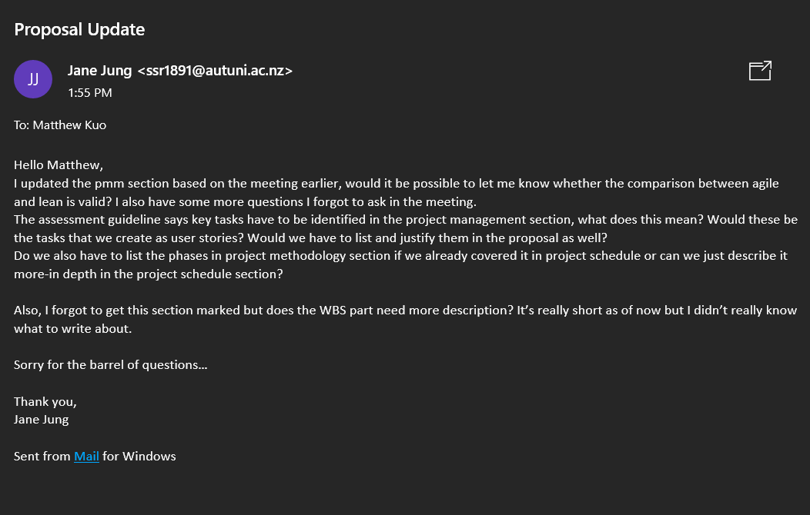

## Entry 26: Week 5 Workshop

### Notes

Quality management (QM)

* Defines/tracks the quality attributes of the requirement which the project must deliver
* Ensures product delivered is fit for purpose
* Enables learnings for continuous process improvement in project

Ways to ensure quality in our project

Must be clear on following:

* Pm methodologies/phases (wbs)

Knowledge + understanding of tasks and techniques/practices used for undertaking tasks and resulting artifacts + how they are validated

* Quality attributes of project requirements

Identify quality attributes of the requirements (understandability, correctness, testability, usability etc)

* Qa plan

Write walkthrough procedures for undertaking phase tasks using adopted practices/techniques

Prevents errors and defects (in plans, documentations, models and code)

Focuses on entire project life-cycle (through various phases and activities)

Ensures adopted practices/technique rules/standards/checklists for projects are used/implemented (verification)

A proactive process to recognize project flaws

* Quality control (qc) based on qa plan

Aims to detect defects in plans/design/code/error messages including not having consistent interface and identifying usability issues. Ensures artefacts produced are accurate/reliable

Qc validates/ensures practices/techniques/rules/standards identified in qa plan are being used correctly

Identifies and fixes bugs, corrects/modifies techniques and practices

QA vs QC

Quality attributes of functional/non-functional requirements

* Understandability
* Correctness
* Testability
* Learnability
* Usability
* Reliability
* Portability
* Efficiency
* Maintainability
* Security
* Flexibility

QA and QC

Implementation (development/testing) phase

QA procedures for testers (unit testing, integration testing and systems testing etc.):

Must log the bugs into the issue tracking system when identified during testing

Standard for capturing the bug

Date/time

Where its observed

Identify steps to reproduce bugs

Provide screenshots

Produce end of day bug report

Produce weekly metrics (on each testing)

QC-testing done by the testers

Carry out unit testing

Carry out integration testing

Carry out systems testing

Log bugs and produce daily + weekly bug report

Source for improvement of QA procedures for planning, analysis, design & development (including testing) phases in the project

Proposal- due week 6

Must have following:

1. Cover sheet
2. Executive summary
3. Project proposal details

Day/time for presentation: team to make arrangement w mentor/mod

Meeting room booked by mentor- let him/her know

Face-to-face on campus presentation

Duration: about an hour (10 mins for presentation and 25-30 minutes QA)

Compulsory, every team member needs to take part

Let mentor/mod if there was lack of participation from a team member

Written feedback should be expected at the end of week 8

Expect a verbal feedback and outcome during the presentation

Everyone must be familiar with proposal

Dress smart

Must be ready to start presentation on time

Get permission to record presentation

10 mins for presentation

No more than 7 slides

Capture key points

Include issues/challenges faced so far

Highlighted some key risks which may emerge during the project timeline

Everyone must talk

25-30 mins for QA. Help your team member to answer questions

Q/A- if you can’t answer a question ask someone in the team to answer it. Don’t makeup, just say we or I did not consider it for the proposal. (Truthful, take criticisms and take suggestions on board to get better'

Take notes on suggestions

Upload completed proposal document on canvas

## Entry 27: Self-directed work

I followed Matthew’s email and rewrote PMM section to go into more detail about how kanban will be applied to our project. I also rewrote the WBS to clarify the key tasks as well as subtasks, and added more information on how to divide the key tasks in the WBS during the development stage of our project. I also added the kanban implementation to the appendix.

## Entry 28: Team meeting (online)

We had a team meeting to discuss the presentation, as well as to create a foundation for the slides for our presentation. Like the proposal, we decided to split the creation of the PowerPoint slides into sections for different members, with members assigned to the same slides as they were for the proposal. I was assigned to the project methodology, the project schedule and issues faced so far during the project. Our team was worried that there were no specific criteria established for the presentation aside from the basic instructions, so we decided that we should spend the last mentor meeting with Matthew to get some feedback, as well as to hopefully run a simulation Q&A session.

## Entry 29: Self-directed work

Following the team meeting, I added info to the slides related to project methodology, issues faced so far and project schedule. However, I was concerned about exactly what content was relevant as I didn’t want our team to spend too long on the presentation.

|  |  |
| --- | --- |
|  |  |
|  |  |

## Entry 30: Week 6 Mentor Meeting

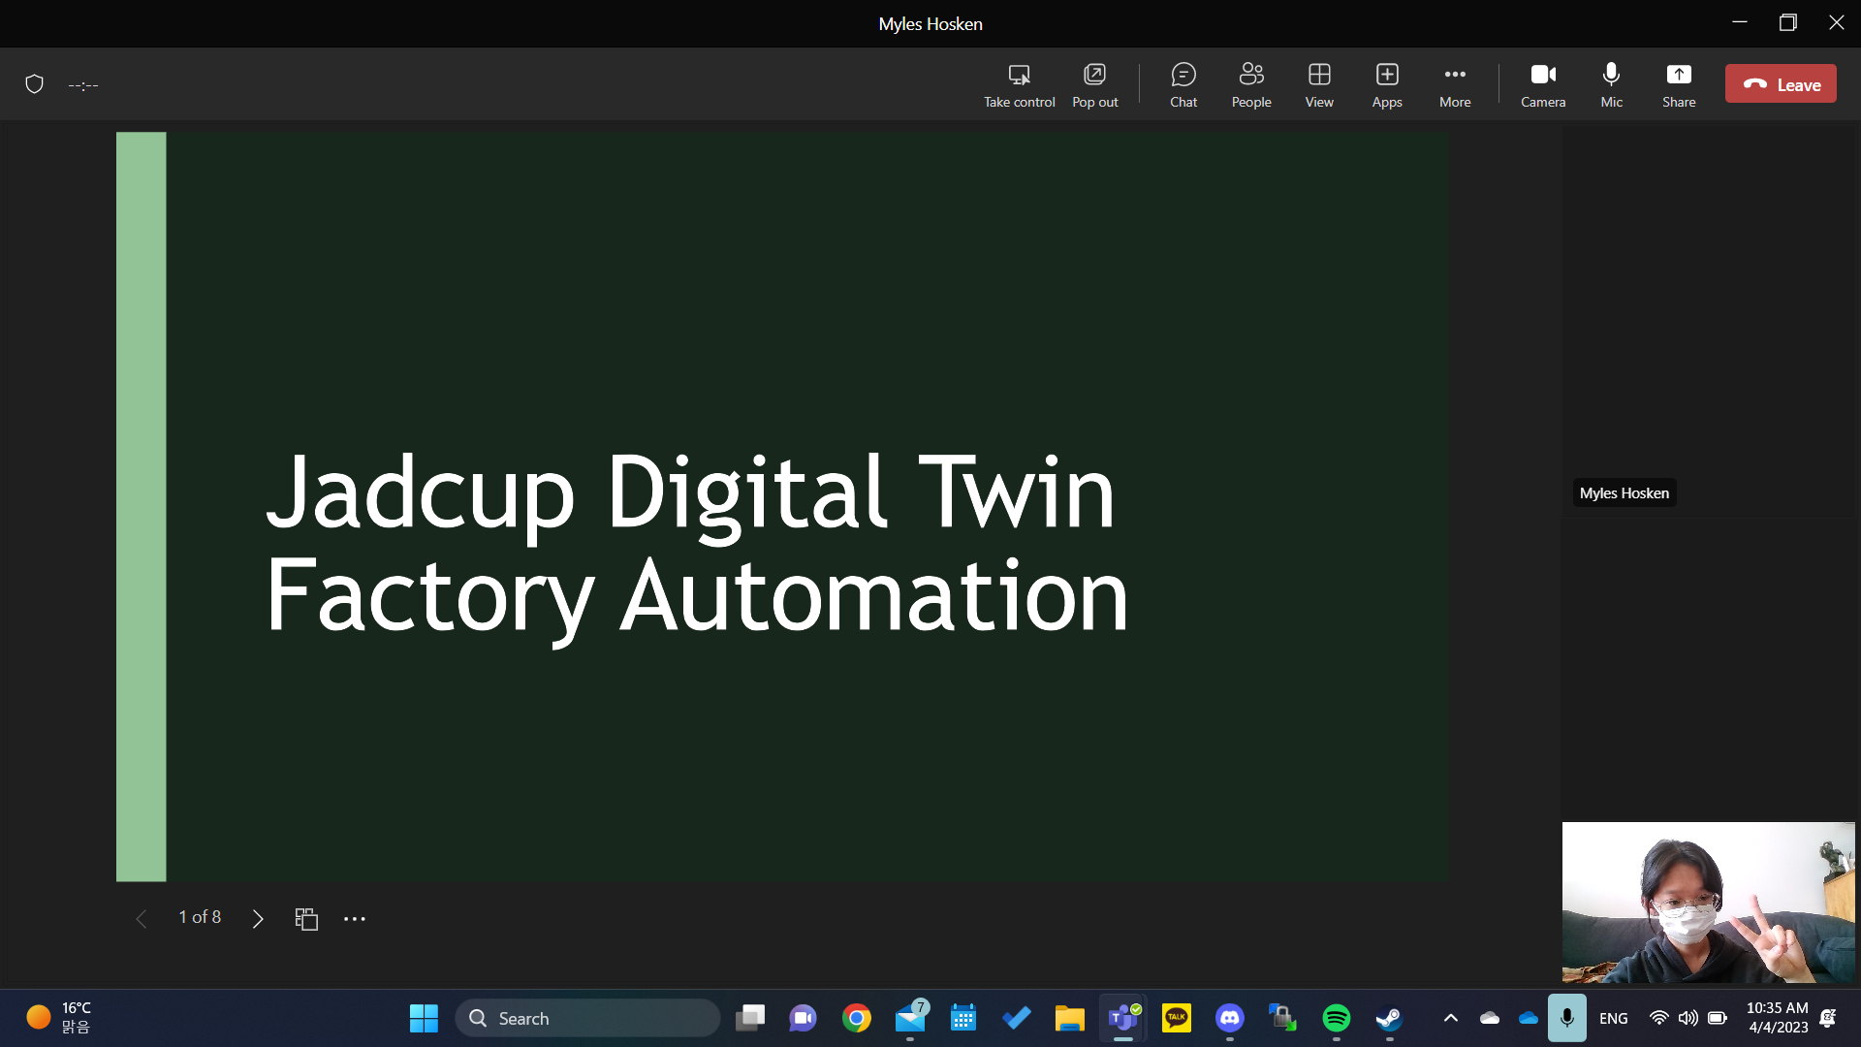

Because one of my parents tested positive for covid, I was unable to get to the meeting in person as I had to take care of her until my dad came home to take over. I attended the meeting online, and took Matthew’s feedback with the rest of the team, and modified the slides as following:

* Combine issues/risks.
* Add an upskilling schedule.
* Focus on kanban for project methodology and expand on phases.

|  |  |
| --- | --- |
|  |  |
|  |  |

## Entry 31: Proposal Presentation

The presentation was carried out with everyone on the team (I managed to get there in person) and with Matthew & Tony Clear as our markers. After the presentation, the feedback we received was generally that the project schedule was too vague, and that there needed to be more detail in the development/monitoring section rather than just having 20 weeks written down. I did manage to point out that the project development stage will be carried out in iterations, as described in the project schedule, and Tony suggested that we make more milestones to give us clear goals of deadlines for some tasks despite using kanban, as he was concerned that we would otherwise have no method to track the progression of the project.

## Entry 32: Team Meeting (Online)

We had a team meeting at 9.30am, which I was unfortunately quite late to as I slept in. Thankfully everyone in the team was forgiving as I had told them before that my dad had also tested positive for covid, so I spent most of the week taking care of them. During this meeting we went over the areas in the proposal we needed to fix before we sent the final copy to our client, which was to establish some milestones, as well as to add more detail to our iterations to be used during the development phase of the project. We drew up some milestones, as shown below to create pseudo-goals we wanted to achieve each iteration, as shown below.

|  |  |
| --- | --- |
|  |  |

Although using kanban means that we are more flexible with the milestones, we agreed with Tony that having established within the development phase would be more effective to track our progress. I will be using these iterations to add to our project schedule, and to our proposal so that we can provide a better detailed report to our client.

## Entry 33: Self-directed work

The main feedback we received from Tony was that our iteration cycles were structured too vaguely, and that we should create some milestones to set our project direction. After we came up with some we made sure that the deadlines were in accordance to the iteration dates set on the project schedule. After, I went through the again and added all the milestones, as shown below.



The milestones are represented by a diamond in the timeline, and I added some example tasks for the iterations that could represent how the team would work towards the milestones during each cycle.

Version with just the milestones: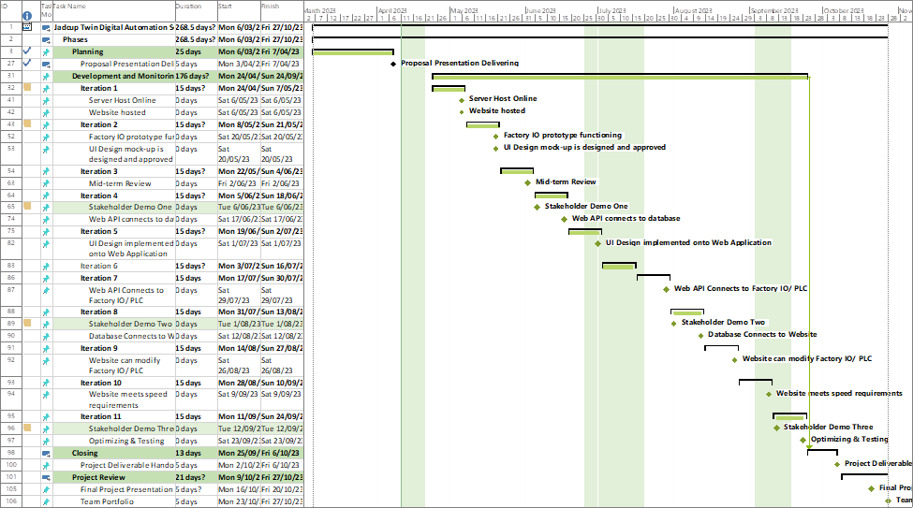

I also updated the upskilling schedule slightly to modify the dates, as the schedule was created before we finalized the project schedule.



After making these changes, we sent the new version to Matthew and Tony for review.



## Entry 34: Upskilling (12/4/23)

**Upskilling field: UX/UI**

researched into UX/UI design of web applications.

## Entry 35: Upskilling (14/4/23)

**Upskilling field: React**

I started to watch some videos about react, and I found a pretty helpful tutorial created for beginners. The explanations weren't boring, and it was concise enough so that even without programming myself I was easily able to remember the coding standards and such.

[React JS Tutorial For Beginners 2023](https://www.youtube.com/playlist?list=PLSsAz5wf2lkK_ekd0J__44KG6QoXetZza)

### Notes

React makes website by creating component building blocks

Function/class components

Function component:

* Js function that accepts props (properties) and returns html that describes UI
* Pretty much just functions
* Returns JSX? Elements

Class component:

* Regular ES6 classes that extend form react's component class
* MUST CONTAIN render method which returns HTML

You can declare multiple different function comps but u need new file? For class component like java

Practicing building react apps below

|  |  |
| --- | --- |
|  |  |

Use props to access inner properties of components

When accessing props in class comp use this. Keyword

Props are immutable/readonly, you cant change the data later on after initial declaration

To make data dynamic, instead of props we use states

States hold info which could change over the lifetime of component which makes it more dynamic

|  |  |
| --- | --- |
| Props | State |
| Passed to component (parameter)  Immutable  Can be accessed as props/this.props | INSIDE component (variable) can be changed functional: access with useState Hook class: access with this.state |

States

Call constructor {super()} to get access to all component commands

Declare variables within state{} <- JSX

When returning JSX, they must be wrapped inside a parent element

Remember when you call functions on event handlers you remove () at end otherwise will activate onload as well

Binding functions ensure function always accesses specified component instead of getting parent component

Changing state in function component: const[x, setx] = useState()

* X is a variable, and setx is the function that accesses/changes x
* useState creates state of variable and the function. useState(0) would mean any variable would be set with 0 (parameter can be string or any other variable type)

Conditionally render elements

* UseState can be used to decide onload whether an element should be rendered or not <- good for toggle buttons (on/off)
* Can also render components instead of just messages
* Use a result element to represent which element should be displayed

e.g. let output; if true, output = this; else, output = that

* Can be represented with ternary format as well output = condition ? Res1 : Res2

List rendering

* When rendering lists, try and avoid combining the list looping process with the list rendering process- aim is to make return statement as simple as possible

Rendering object lists

* When rendering object lists, it is recommended to map it into a 2d array that contains an id attribute which is used as the key to ensure individuality of elements (or use array index of element).

Handling user entry

* Similar to html, but we need to add onChange property to input element if we want to dynamically detect changes made to the input
* This keyword is so confusing
* To make input value dynamic: need to declare state onload, and the value of the input needs to be referenced to the state. Then, the event's target called in event handler will point to the input component, and will rerender the value within dynamically as the input value changes.

Form submission

* Add event handler to form element in JSX
* Event.preventDefault() prevents page from reloading when a form is submitted

### Reflection

Everything so far seems pretty manageable and I think it would be relatively simple for me to adapt to our project- my only concern is with npm as I keep getting errors when I try to create new apps, and even after I create them I keep getting disconnected from the server

## Entry 36: Upskilling (15/4/23)

**Upskilling field: React**

I followed the tutorials that were provided in the playlist mentioned above: there was a section dedicated to making a todo list online, and I tried to follow the videos and recreate it myself.

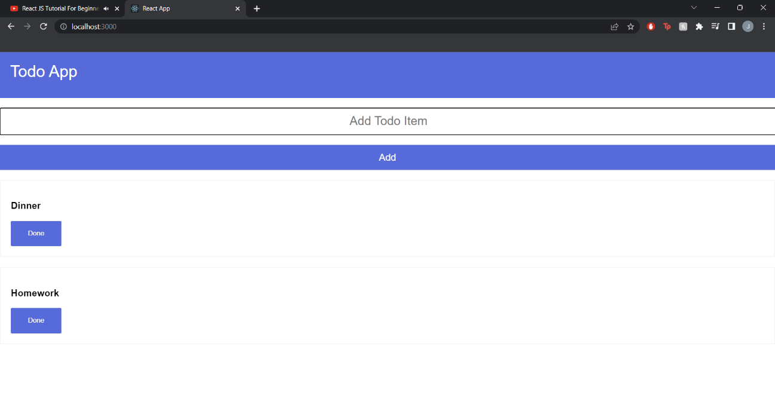

Full code will be included in the individual folder within team portfolio

The main issue I had was installing and running react as well as updating the subfolders, I kept getting minor errors whenever I tried to launch the react app. I ended up having to use my desktop which had react installed previously, and I was able to practice programming with react components.

I am feeling pretty confident with react programming on its own, as it's a simpler version of JavaScript which I'm already familiar with. Initially I was overwhelmed because the format seemed to be completely different to JavaScript, but I've realized it's just a more OOP version of it, which doesn't seem so bad.

I also found out VS code has a git library built-in, so I can commit changes as I work within the app instead of having to open GitHub every time.

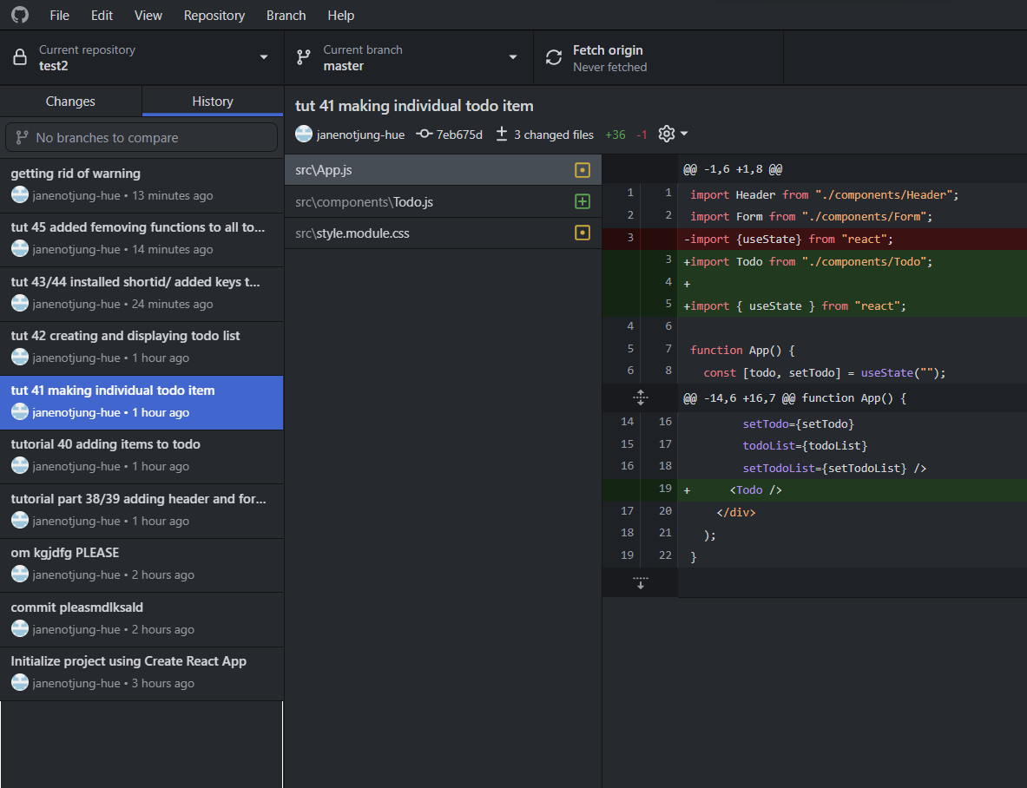

It's also easy to connect to the repository on GitHub and see the commit history later on as well.

## Entry 37: Upskilling (17/4/23)

**Upskilling field: react/node.js**

Finishing off the react tutorial playlist (0.5hr)

### Notes

Fragments

* Fragments group child components together without having to create a new node group (React.Fragment or just empty </>).
* Example use: columns within tables can be returned directly instead of being encased in divs

React Memos

* Assume there is a parent A node with child nodes B and C
* If parent A becomes re-rendered, the child nodes will also be re-rendered by default, but constantly re-rendering child nodes B and C when their values remain the same wastes time and reduces the performance of the app.
* By using memos in react (export default React.Memo(element)) you can remember the values contained within an element, and prevent an element from being re-rendered even when parent becomes re-rendered unless there the value of the child itself changes.

Portals

* Used when you want to add elements outside the root div element, e.g. modals (pop-ups) <- could be used for form validation

**Node.js**

Started reading/watching about node.js (1.5 hrs)

[Node.js Ultimate Beginner’s Guide in 7 Easy Steps](https://www.youtube.com/watch?v=ENrzD9HAZK4&ab_channel=Fireship)

* Nodejs is a runtime method that allows js to run on servers, and not just on web pages
* It isn't technically a new language
* Similar to php- gets input from client, and sends it to the server, and sends the server response back to the client

Main differences between node and js

* Node contains a lot of built-in identifiers
* Identifier "global": makes something accessible anywhere in code (similar to window in html)
* Asynchronous- event driven, allows for processes to run as soon as they can regardless of order they're called
* Listens to events and activates a callback function like js

W3schools tutorial

<https://www.w3schools.com/nodejs/>

Advantageous over php in the fact that it doesn’t wait for the server to finish processing a task before starting another one

Node js module = js libraries

Similar to eventhandlers in js, but the events are specific to server actions

<https://www.w3schools.com/nodejs/nodejs_mysql.asp>

Node js with MySQL

### Reflection

I'm pretty confident in react now, and node js itself doesn’t seem too different from PHP in the format of processing information from databases. However, I've been getting errors when I try to establish connection with the databases, which I haven't been able to figure out.

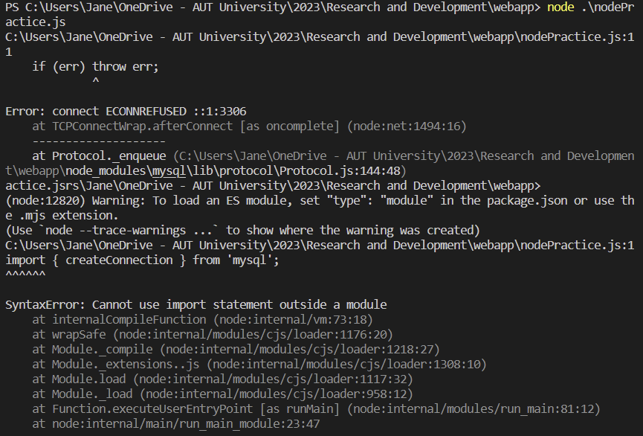

Since we aren’t using mysql for our database and I'm not really assigned to the database, I'm not too worried about this part, though I will probably ask my teammates about some of it later if I need to.

## Entry 38: Upskilling (20/4/23)

I spent some time watching tutorials on accessing firebase using react and node js

[How to Connect Firebase With React Application](https://www.youtube.com/watch?v=ad6IavyAHsQ&ab_channel=SmallAcademy)

I knew that Myles and Yeran were going to mainly oversee the firebase aspect of the project, but I thought it would be worthwhile to at least know the basics on my own. Sending and retrieving data doesn’t seem to be too difficult.

## Entry 39: Mentor meeting (online)

We had an online meeting with Matthew to update him on our upskilling progress, and to confirm with him about the tech stack we were planning to use. Most of the time the team asked him questions about firebase, licenses for the programs as well as whether Daniel was going to give us access to the source code.

## Entry 40: Team meeting

Front end things again, joined for a bit and saw that we had a new firebase account, then separated to start working on the website and how we could structure it. Asked Harshil to upload what hes done so far, he did it like 2 weeks later smh

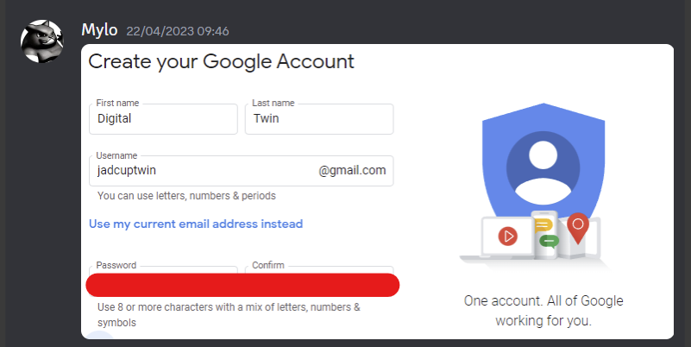

## Entry 41: Upskilling (24/4/23)

I also tried to make a practice database of my own following this tutorial:

<https://javascript.plainenglish.io/getting-started-with-the-fern-stack-firebase-express-react-node-js-2a97b93bd920>

I succeeded in creating the database itself (websitedbtest), but afterwards I was blocked at establishing connection as I needed to pay for a connection apparently. I also didn’t really understand firebase as a platform independently from react, so I had some trouble differentiating between the real time database and firestore database. I'm not too worried about this as I can ask the other teammates once they succeed, but it was still frustrating to try and figure out without potentially damaging the other projects on the account as well.

## Entry 42: Upskilling (25/4/23)

watched some videos specific to google firebase and its implementation using node js

[Firebase with NodeJS & Express - CRUD Operations(API)](https://www.youtube.com/watch?v=YPsftzOURLw&ab_channel=SyedZano)

Also started watching a tutorial that uses react to build an admin control panel

<https://www.youtube.com/watch?v=wYpCWwD1oz0&ab_channel=EdRoh>

## Entry 43: Upskilling (26/4/23)

Continued watching the video mentioned above.

## Entry 44: Team meeting (online)

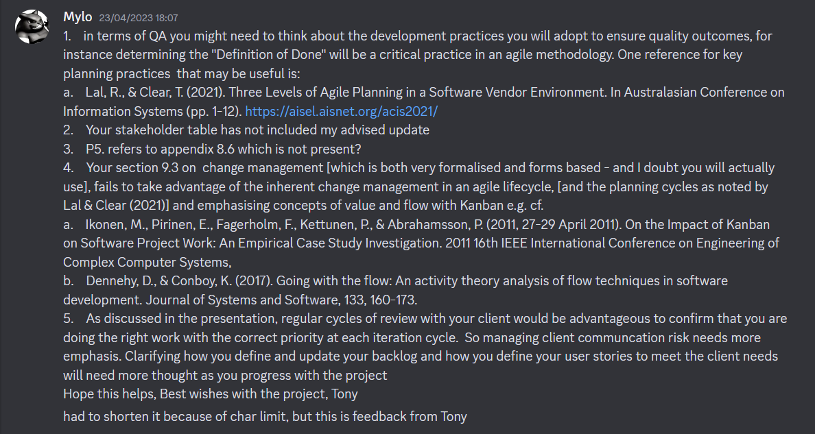

Previously, Tony had sent Myles a list of changes he wanted us to make to the proposal. We spent some time discussing the topics he wanted us to improve, and whether we needed to make these before we next saw Matthew. We ended up deciding that the changes could probably made later before the mid-sem review and that we should focus on the development, since the marks for the proposal would have already been finalized.

We then started adding some cards to our as well as adding labels to easily distinguish tasks.

|  |  |  |
| --- | --- | --- |
|  |  |  |
|  |  |  |
|  |  |  |

After, Myles brought up a concern about the lack of meetings we were having, as well as the productivity during these meetings. Because we were meeting early on a weekend, everyone was too unmotivated to focus on the project, and a lot of the members also had part-time jobs which led to a lot of the meetings being held with at least one member absent. To mitigate the risk, Myles suggested that we change the meeting time to after the weekly mentor meetings we have on Tuesday, like we had done a couple of times before the mid-semester break. Because the workshops were only up to week 5, everyone was now available from 12pm-4pm, which Myles suggested we use for the project development. He asserted that we wouldn’t have to spend 4 straight hours if we did enough work to satisfy us, and that we could always still meet up on Saturdays as well if we felt like we needed to. Everyone else of the team was also aware beforehand of the risks of virtual meetings and weekend meetings not being enough, and how it could potentially become a major threat to our project’s completion, and so accepted Myles’ suggestion.

## Entry 45: Upskilling Reflection (30/4/23)

I didn’t do work every day as planned, and there definitely needs to be upskilling done as I am developing, I thought I’d only need to structure the website (UI), but I became aware of the fact that realistically, I would also have to interact somewhat with the database as well as frontend together with Harshil, as I cannot let him do all the work for frontend. I’m having a lot of troubles with firebase as well, so after the break is over and I get to meet everyone in person, I definitely will be asking the others about it more. Additionally, I also missed a few meetings over the break, which reduced the opportunities for me to talk to my team and discuss potential strategies before the mid-semester break ended.

## Entry 46: Week 8 Mentor meeting

Everyone met up at 9.30 before the mentor meeting, and during we added swimlanes following Matthew’s advice and received a license for factory IO- just 1, but it can be used by everyone if we aren’t using it simultaneously. In regard to changes suggested by tony, Matthew said that we didn’t have to make changes to the proposal now, but recommended that we make these changes before the mid-term report. He also wanted us to at least create a prototype for the website soon, so that we can confirm the design with the client.

## Entry 47: Team meeting

After the mentor meeting, everyone spent some time together to mob some work. During this time, I asked everyone else for help with installing node js, as well as branching off from the main branch in github. We also tested Harshil’s website to see whether it would be compatible with the code Myles had written so far to connect to firebase, but we decided against it.

## Entry 48: Self-directed work

To prepare for our web application, I went through the photos we had of the interface and made a table to show all the variables provided. When going through the photos, I noticed that there are no units on most of the numbers, and there were also cases of 2 values assigned to one label. There’s also no clear indication of what components from each page are interactable and and what parts are disabled. Additionally, some pages seemed to refer to the same values- represented by the blue cells on the table below.

|  |  |
| --- | --- |
|  |  |

I then created a sort of database diagram to try and map out all the overlapping values, shown below, to try and make the identifying the location of each value easier. Although I am aware realistically, it would probably be difficult to create a prototype that represents all of these values for the web application, it might be useful to have in advance later in the project.

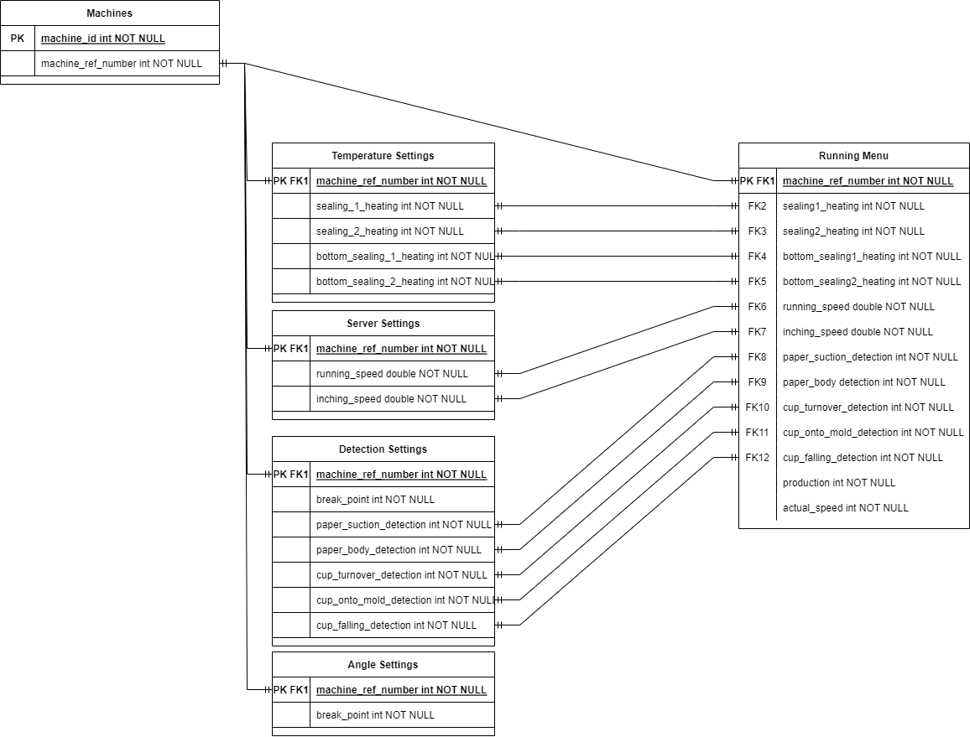

## Entry 49: Self-directed work

I created the template for the mid-term review report following the requirements list set on canvas before the meeting, as I knew we were going to spend some time taking Tony’s feedback and hopefully start the status report.

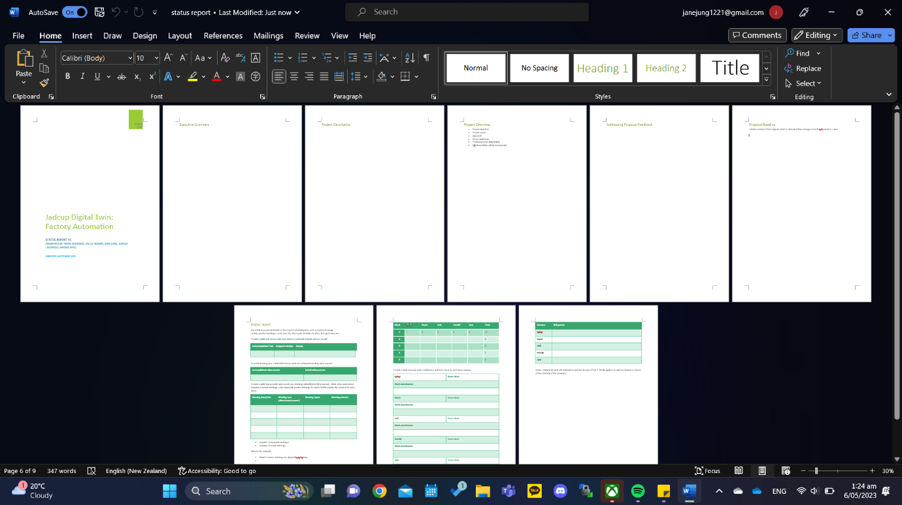

## Entry 50: Team meeting

We had a brief discussion for the status report and the requirements for it, as well as how we were going to make changes to the proposal before the mid-term review. I let everyone in the meeting know the report template was uploaded, and we could probably take some parts from the proposal to fill it in.

## Entry 51: Self-directed work

Started to format file structures the way instructed by the week 6 lecture.

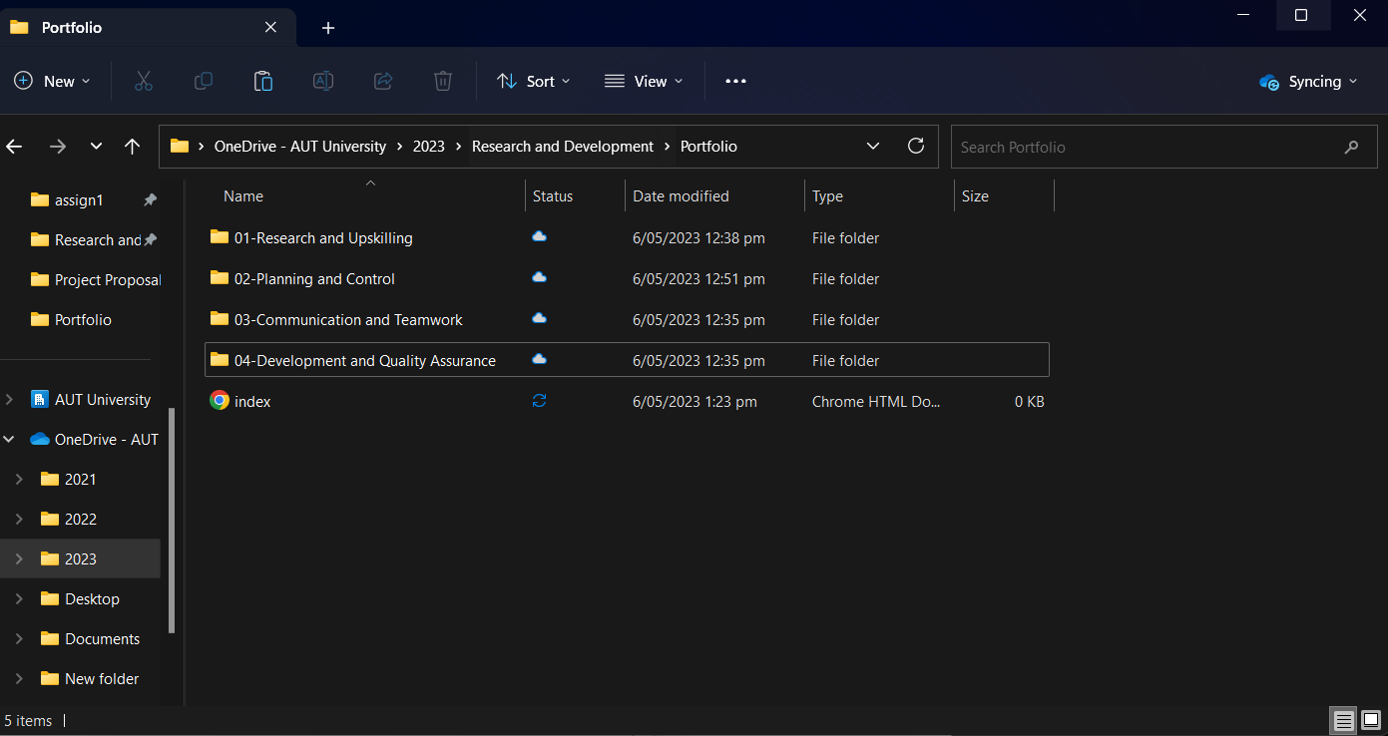

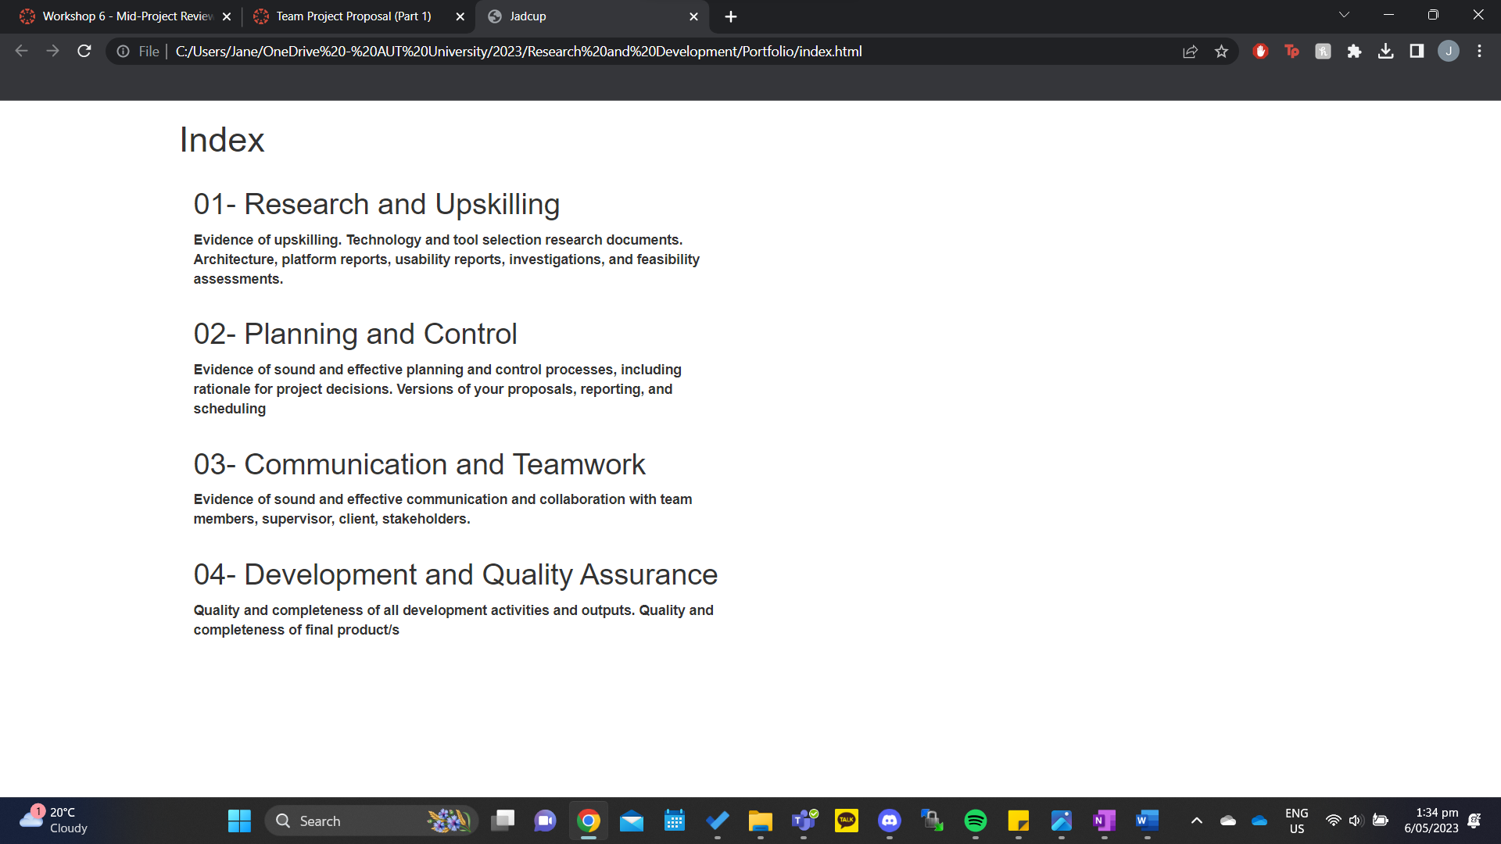

|  |  |
| --- | --- |
| Research and Upskilling    Inside individual folders: | Planning and Control |
| Communication and Teamwork | Development and Quality Assurance |

In the planning and control, some plans are saved in their own directories, as I saw that we were also supposed to provide different versions of our proposal, reporting and scheduling. Below is an example for one of them, project proposal. I tried to gather all the major versions of the proposal created so far, and included a guide that summarized the changes between the different versions.

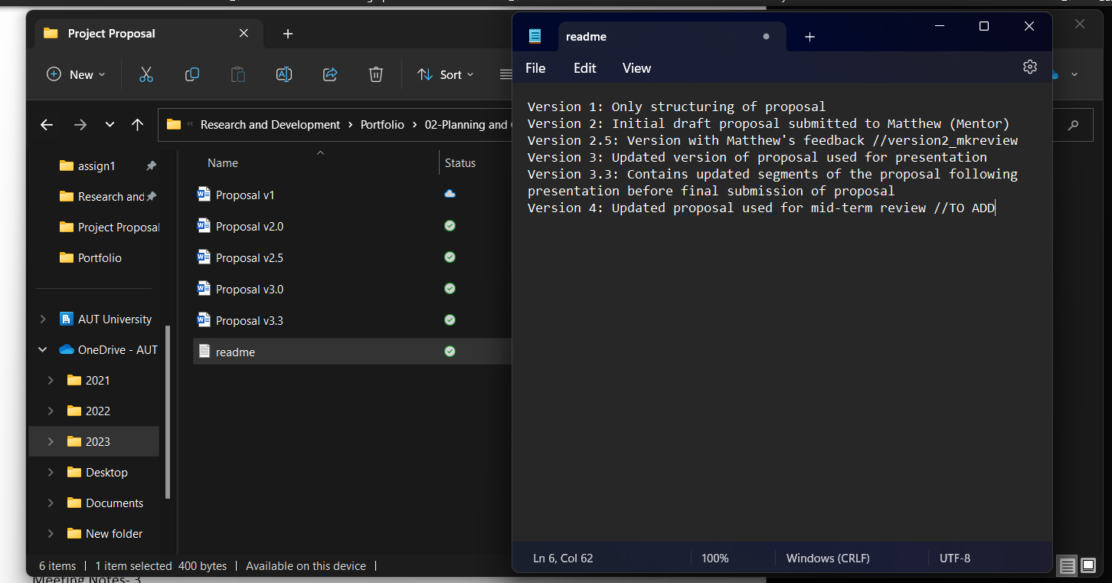

I’m not too sure about the classifications of the files I currently have, so I plan to ask Matthew about it in the next mentor meeting. I also want to ask about the index website, and how we’re supposed to structure it.

## Entry 52: Week 9 Mentor meeting

*Yeran was absent because he got into an accident on the way to the meeting

### Notes

Web application

Units on website don’t have to be accurate

Make some dummy data so represent unimportant values

Still show the all the buttons (need all the input/output buttons)

Only send some of the data transferrable to the middleware

Factory I/O

Licensing issue- we aren't able to use the factory IO program because our license isnt working

We could build the prototype without the license

Milestone report- report we've run into issue regarding created working prototype

Make elevator? Version, use that while we make real one

Sensors control real machines but in the simulator we have to control manually

**Main issue: how close of a relationship do we have to maintain between our simulation and the real machines**

***Middleware should not control things***

Logic should only be in PLC

Worklog book- do we have to have 110 hrs? Matthew: yes

Portfolio:

Index- write code to generate the links for each file

Versions- if the file has several versions, put them in, otherwise just dump actual files

4 Code reviews/acceptance test things/pull reviews on github (add branch protection) slay Myles

Todo:

Also have to rewrite proposal

Write status report

Get 2 deliverables finished (milestones) before review

Add to issue log

* Factory IO license

## Entry 53: Team meeting (online)

Because there was a risk of flooding on Tuesday, we pushed the mob work session to Friday (today), and everyone except yeran met up (he had work) to update the proposal based on tony's feedback below so that we would be able to ask Matthew for advice during the mentor meeting next week. 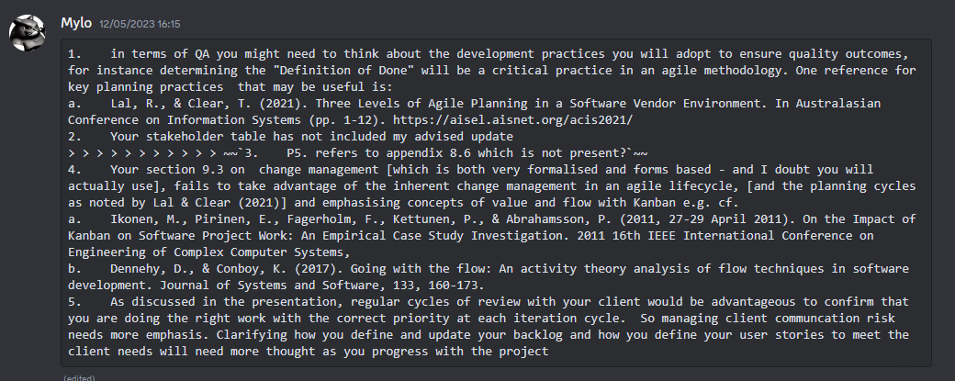

1: Josh started updating the qa part of proposal and added def of done section

2: we can’t remember exactly what Tony wants, ask Matthew

3: updated table

4: spent the most time on this, removed change manage form and updated change manage plan so that our plan matches our agile lifecycle, and we gave more detail as to how we were going to make changes at each iteration based of task value and priority

5: Harshil updating risk register/ I need to go into more depth for each stage within the iteration cycles

## Entry 54: Team meeting (online)

Meeting evidence:

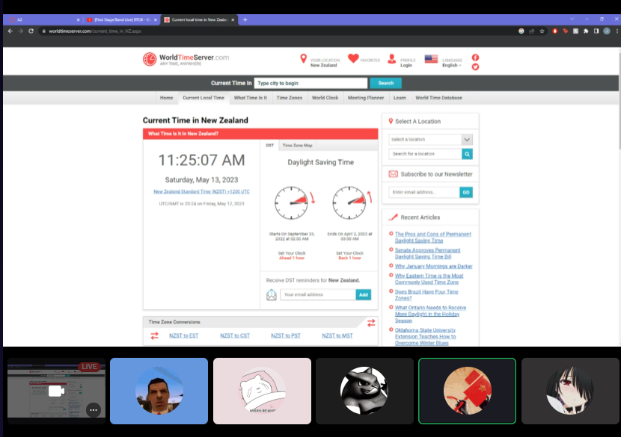

We had a meeting to go through the proposal and we confirmed the changes we started the night before. We made sure to log the changes we made into our chat to make sure that it would be easier to find changes made in the different versions later if required.

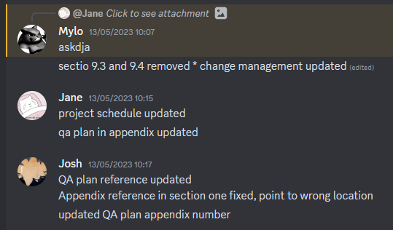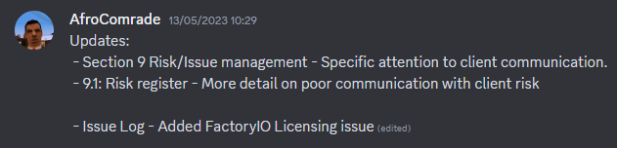

We also started to fill in the meeting documentation table in the status report by going through everyone’s worklog books and cross-referencing the meetings everyone each attended.

Meeting date/time 
06/03/2023 6pm-8pm 
07/03/2023 1 lam-12pm 
14/03/2023 9-12:30pm 
16/03/2023 Ipm-2pm 
18/03/2023 gam-llam 
21/03/2023 9:30am-10am 
24/03/2023 gam-12pm 
25/03/2023 gam-12pm 
28/03/2023 loam-llam 
30/03/2023 3:30pm-5pm 
Meeting type 
(client/team/mentor) 
Kick-off Meeting 
(Team) 
Team Meeting 
Team Meeting 
Client Meeting 
Team Meeting 
Mentor Meeting 
Team Meeting 
Team Meeting 
Mentor Meeting 
Team Meeting 
Meeting topics 
Meeting minutes 

## Entry 55: Week 10 Mentor meeting

### Notes

Questions:

To Do confirm w Matthew to the changes of proposal (change management)

To Do do we need to update the proposal to match current timestamp like meeting records (no)

To Do ask about stakeholder table (ask tony)

To Do ask him to tell Daniel to respond

Factory IO:

Factory IO model is good

Status report:

Focus on the processes, (e.g. how we're using kanban)

Report on upskilling

Proposal

Stakeholder table: just email Tony lmao

Include new risks (Factory IO licensing issue)

Update process flow methods with kanban

Change management plan

How will we manage different types of changes

Technical change management

Client requests

Management methods when client doesn’t like change

Iteration phases should give specifications of how we execute actions in accordance with Kanban

Quality assurance- we should reflect on the QA processes written in this section and whether we're following them or whether we should update the plan before mid-term review (we need to make sure we are able to provide evidence of us following QA plans when we're developing project)

Team meetings

We should still keep sat meetings

We also need to meet on Tuesday

There needs to be a designated person that regularly updates Trello board

Plan

Add more values onto the current prototype white Jadcup is being developed

Simplify web app- just show examples of different components and important components (e.g. power button)

If we want mock values, we should actually get it from the factory io simulation instead of creating just a js script (make sure it goes through mod bust)

We should def have a UI prototype to show with status report

Discuss whether we're going to meet up over the break

### Reflection

Matthew’s main concern was that we were falling behind on creating the UI prototype of the web application, as he considered it to be an important component we were going to be assessed on during our review and advised us that we prioritize the UI draft and ideally finish it before the end of the week before continuing with the technical component developments, and that the draft right now would be fine showing just a few values that could demonstrate the different interactions provided on the application.

## Entry 56: Team meeting

Following the mentor meeting, the team did some mob work to update the proposal changes according to Matthew’s feedback. In the proposal, we added a more detailed description of the processes we were going to use for change management and how the processes related to the Kanban methodology.

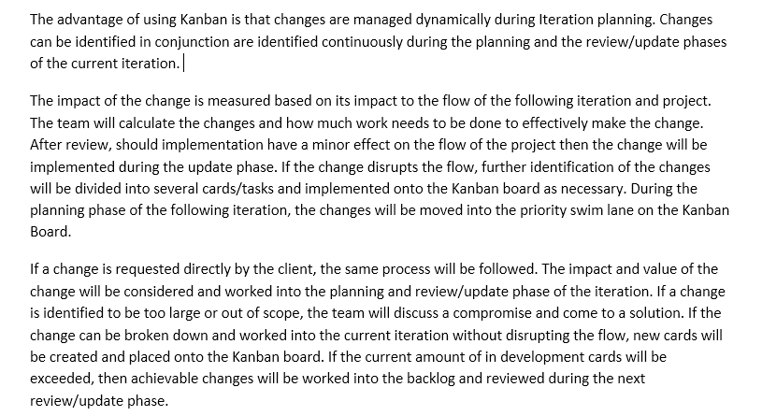

We also followed Matthew’s advice and started creating some UI drafts of the website, which definitely was much easier doing in person with others rather than online. We used pen and paper for the sketches during the mob session as shown below, and later created a more high-resolution static version on a device.

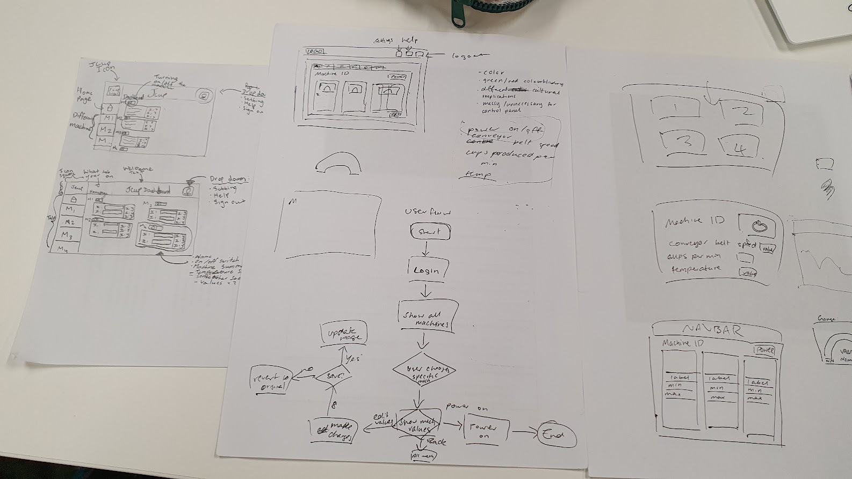

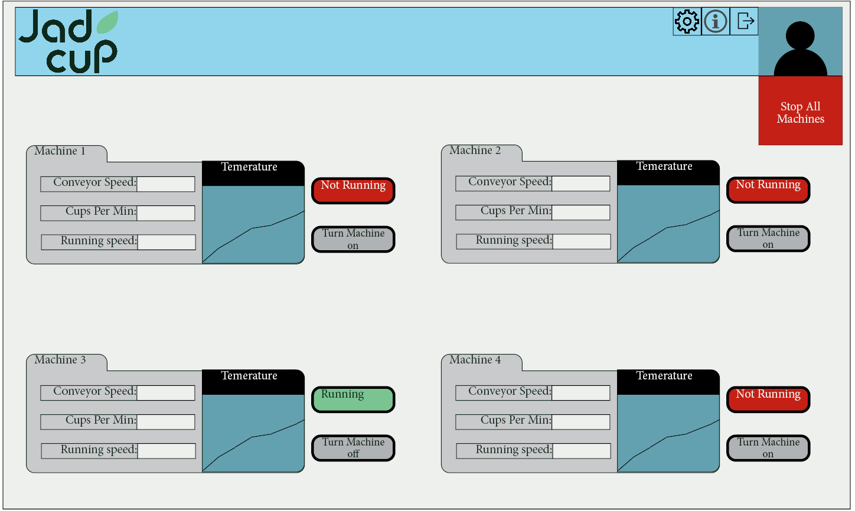

## Entry 57: Mid-Term Review Workshop

### Notes

Mid-term is 10%

2 requirements

1. Write status report

Work done from week 7 to week 12 + mid-sem break

- evidence of work done (artefacts/docs) in team portfolio

- evidence for individual work contribution must be in individual worklog book

Improvement done on rpoposal based on feedback (proposal baseline- ready to be executed)

1. Presentation of status report (ONE SLIDE) + show/tell portfolio + individual worklog book

Presentation is at week 12 face-to-face

Panel: r&d team, mentor, mod, r&d teaching team (NOT CLIENT)

Organize w mentor/mod for a time in week 12

Mentor should book room

Every team needs to present SR in week 12 regardless of when they presented proposal

We get 15 mins to present team portfolio

Presentation is limited to one slide only

Content based on SR

Rest of time is portfolio presentation

Outcome will be presented 10 mins after presentation

Status report

Upload sr on canvas and email to mentor/mod a few days b4 presentation and cc project leaders

Upload copy in team portfolio as well as project presentation slides

Why status reports?

SR summarizes a project's overall schedule against the project plans

Goal is to keep all stakeholders informed of progress, identify issues & risks and potential strategies, and show project will be delivered within the allocated time frame

SR is a vital deliverable for project stakeholders for decision making

* Sponsor
* Client
* Pm team
* Program management
* Portfolio management

SR R&D requirements

Provides info on team's progress towards the goal to

Deliver project objectinve

Complete paper objectives

Apply knowledge and learn new skills (technical/non-technical)

Must provide general update at glance

No more than 5 pages including cover page

Must be professional and HONESTLY provide current project status

SR structure (download template from canvas)

* Title page (team name, date, version, team, supervisor names)
* Executive summary
* Brief project description
* An overview of project objective, scope, approach, major milestones, and product and project-related deliverables- these will be in your proposal
* A response to how the proposal feedback/recommendations have been addressed
* New variations from the proposal baseline with a rationale for them (any recent changes done to the proposal or a plan(s))
* Summary of current project status- work completed and work yet to be done, which should have been done by now & why not done; risks and issues that impacted your plans/milestones and project work
* Summary of individual member contribution and hours done, including learning achieved so far in the R&D project
* Recommendations for improving the project team's performance based on project risks and team issues including what would be achieved in part 2
* New schedule (updated) based on work to be done (must show all remaining work to be achieved in part 2)

Mid-term review

SR must identify the current status of the project by providing the following:

* Key artefacts produced based on scope/schedule plans such as analysis & design models, product backlog or work item list, short cycle schedules & plans, first sprint plan etc)
* Provide a table w unachieved tasks w reasons
* From training plan- show achieved/unachieved parts
* Include a table w data from all meetings- client, team and mentor + num of meetings vs actual meetings. Briefly explain the variance and why
* Major risks & issues encountered during project so far and their impact
* Provide a table showing total hours done collectively per week against target of 12-15 hrs
* Provide a table showing work contribution done by each team member
* Provide table of individual learnings
* Make a statement of what will be achieved (scope) by end of part 2. include brief explanation of whether we're behind/on progress/ahead

Although report should br produced by team, individual work should be contributed by everyone individually

Individual

Worklog book

Digital project portfolio of project work to date

Include clear and well defined index and folder strcture that matches marking criteria (use hyperlinks)

Folder structure from this point should match assessment marking criteria

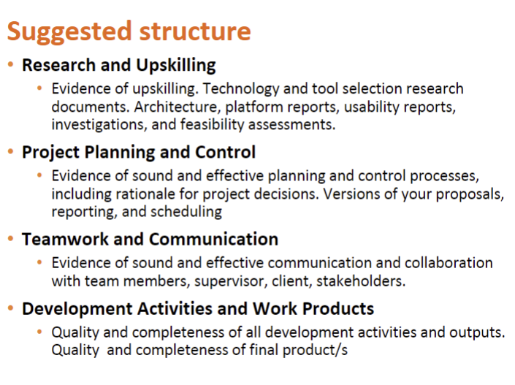

### Reflection

There’s a lot more work for the status report than I thought, not only do we have to complete the report but we also have to make sure our portfolio is organized as well. I think the next team meeting I’ll suggest to the team that we put some more focus on finishing the report or portfolio rather than the components, so that we have the foundation finished and it would be easier to update the changes as we go.

## Entry 58: Self-directed work

I spent some time updating the format of the worklog book, and moving all the notes that I had before on onenote over, such as meeting and workshop notes, as well any notes I had during the upskilling phase.

I also started working on some parts of the status report that were relatively simple such as the table for acquired skills and the number of hours of work done for project. On excel I made a new copy of the skills matrix for everyone to fill out after upskilling that can be added to the portfolio, and will make it easier for everyone to fill out the “acquired skills” table later on.

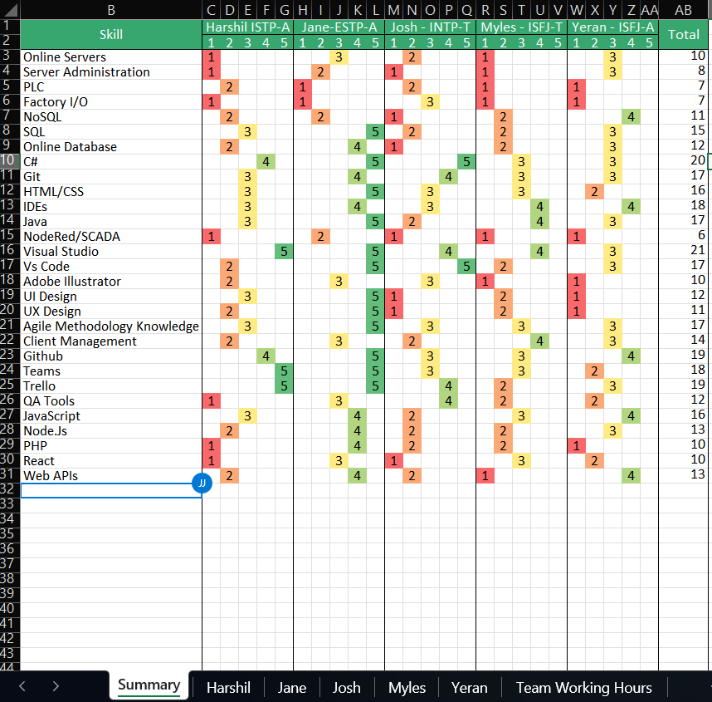

On the same document I added a new page with a table that can also be filled in by the team with the number of hours they each contributed every week, which we can later copy over to the report.

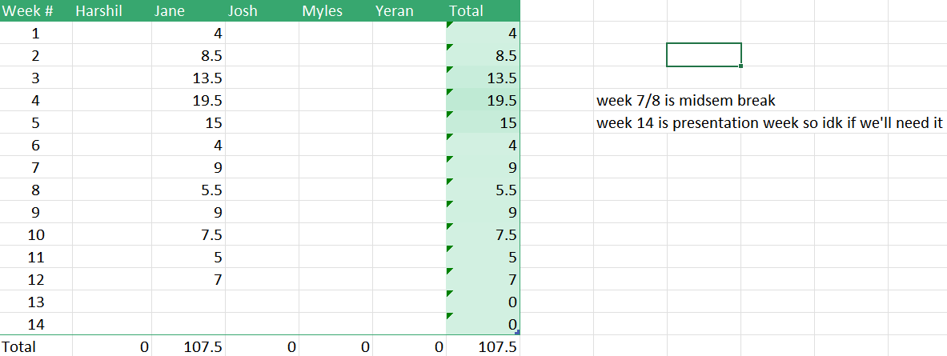

## Entry 59: Self-directed work

I spent some time trying to update the UI prototype, but the version shown earlier was created on Adobe InDesign, which for some reason I was unable to install on my computer. I ended up recreating the prototype on PowerPoint, and I added another page on that provides further details of a machine if a user selects a machine and edit values.

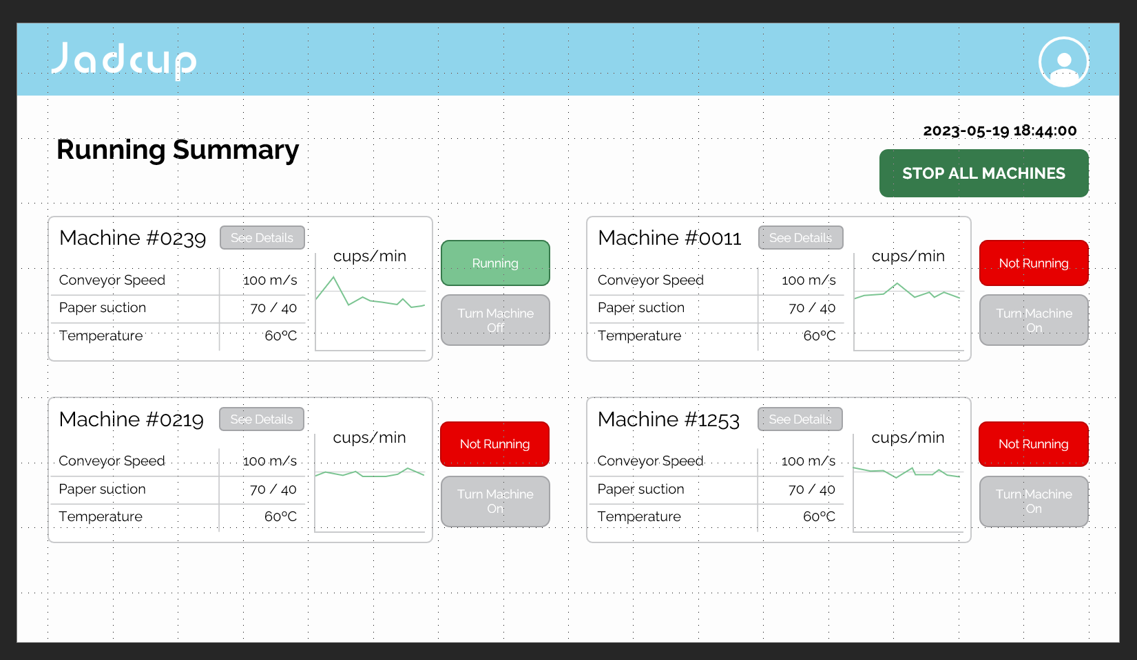

The font was sourced from Jadcup’s website.

### Notes

Potential areas of improvement:

* Show changes that occur when user interacts with the application.
* Try and change up the colour scheme a bit; it seems a little to messy.
* Maybe reformat individual machine info screen, not all the values need gauges.
* Text colour should be darker.
* Change edit button to one icon at top?
* Add save/discard changes button.
* Change button designs.

## Entry 60: Self-directed work

Spent some time updating the file directory on teams, so that we would be able to use it as our digital portfolio. I also added readme files in the 4 main directories to make navigation easier, as well as the root directory that briefly outlines what kind of files each folder contains.

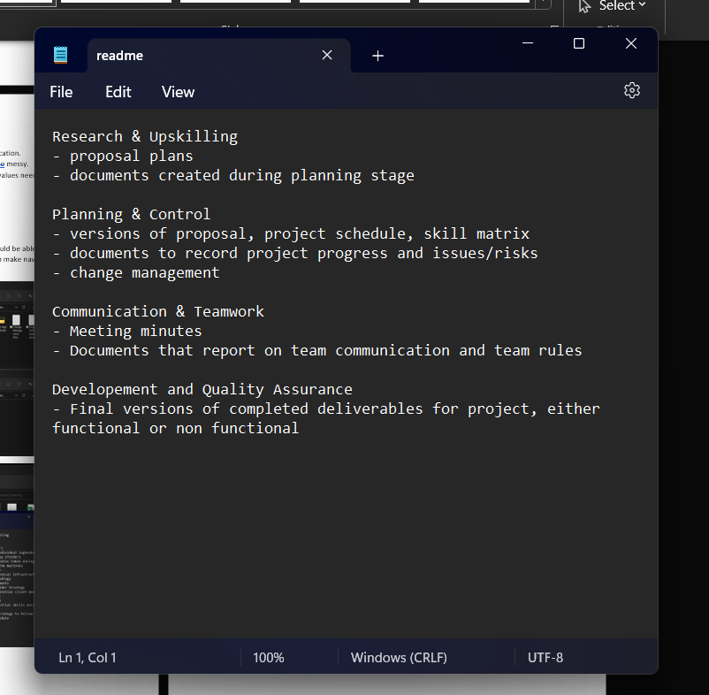

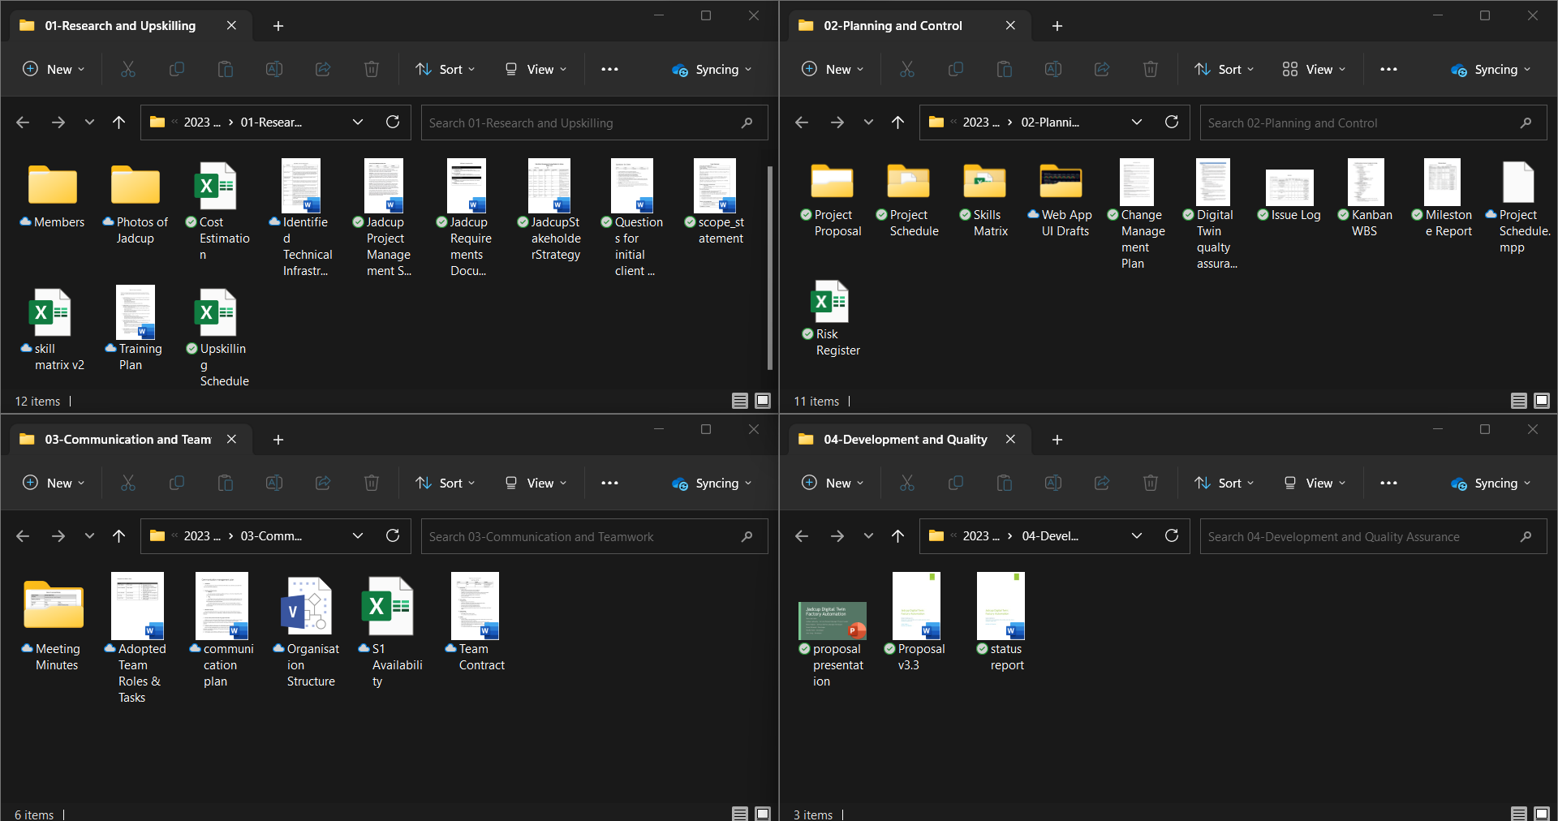

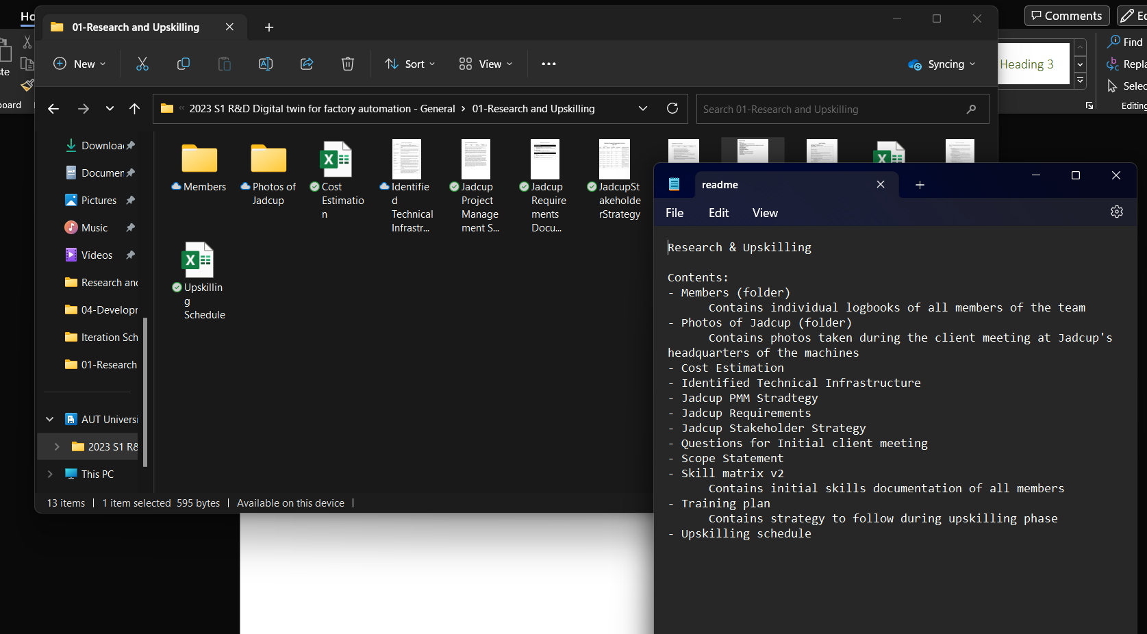

While doing so, I started to wonder whether we would need to have a website as mentioned, since Teams uses an online directory connected to OneDrive, and we could just share that with our submission.

## Entry 61: Self-directed work

Since I knew the backend team had already established a connection to the database, I thought it would be worthwhile to try and make a rough recreation of the UI on the actual website, as it would mean we would have more achievements to discuss during the status report. However, I’m not really confident on that, as I spent 3 hours on making just a dropdown inside a navbar.

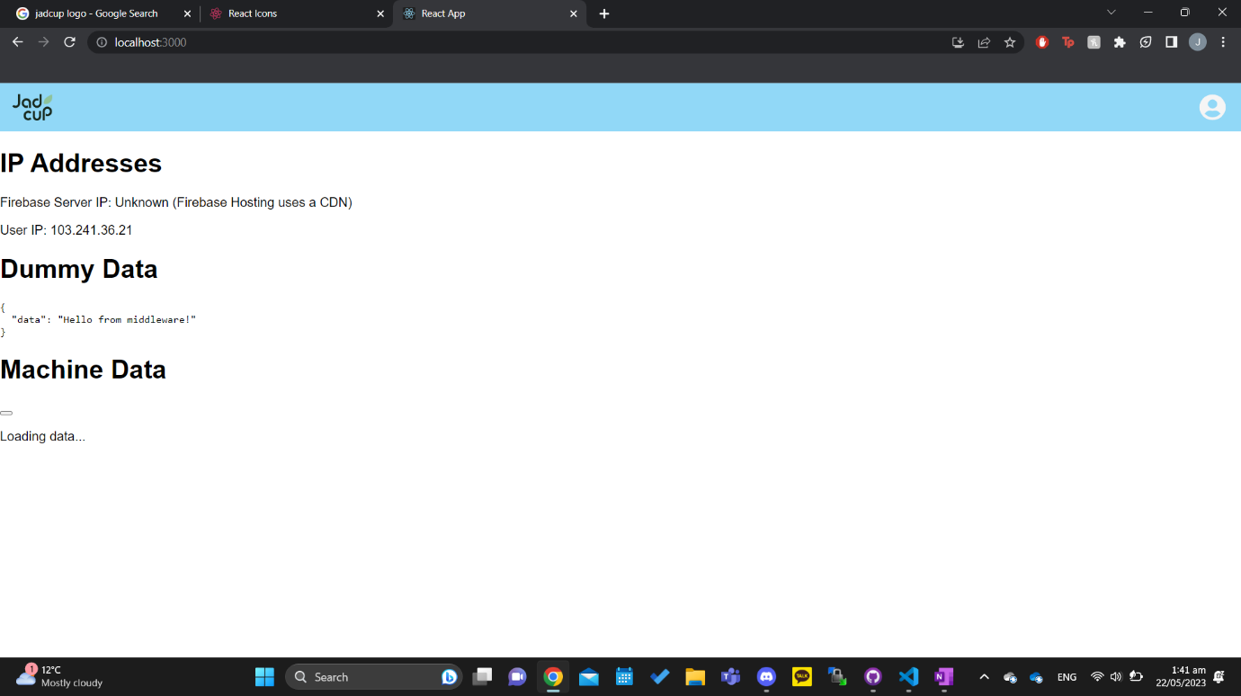

Obviously at the moment its unlikely we’ll have a perfect prototype but its 2am and im hungry and tired so buwe]adad.i committed what I did onto github, so I can disucuss with etam necg time

|  |  |
| --- | --- |
|  |  |

## Entry 62: Team Meeting

### Notes

Meeting todo:

Plan for iteration 3

Plan meeting with Matthew

Status report

iteration scheduling:

for every iteration, on Tuesday I think it will be worthwhile for everyone to spend time together on the Kanban board. during this time we can move the cards around. each time someone does move a card, they should write down WHY theyre moving that card, and what theyre planning to do when a card is in a column (e.g. how theyre planning to develop it)

the outcomes from the discussions should be this:

last week

person - (assigned card) (card location e.g. development) (work done)

schedule for this week

person - (assigned card) (card location e.g. development) (card location) (work to do)

assuming we're on iteration 3 roughly



Ask Matthew if we need new schedule

Ask Matthew about the cards (see trello)

Ask Matthew about testing

Ask Matthew for booking

Ask Matthew about meeting minutes (do we need to make all the meeting minutes)

Ask Matthew to review status report (and ask about page count)

Ask Matthew to confirm proposal changes



Do we need this

Do we need to update old plans in the proposal

e.g. we updated issue log in proposal, do we need to update doc in portfolio as well

Ask Matthew about risks

Todo for this iteration:

### Reflection

Everyone met up before the mentor meeting to mob some work and also set up some of the questions to ask Matthew regarding the status report and mid-term review

## Entry 63: Week 11 Mentor meeting

### Notes

We need of iteration reflections

Do we need to make a new schedule if we're on track? No

We need to reflect too was it smooth or not

Make acceptance tests for all cards, even minor ones

Better to use user story format, if we aren't going to use it give reason why

Presentation meeting: ask Ramesh, can be either next week or week 13 (preferably week 13 6/7 of June)

Meeting minutes are recommended

Documents need to be updated in portfolio, updated documents can be appended to status review in appendix

List of recommendation:

Try make our progress more linear/steady

Send status report/ changes in proposal to Matthew before Friday meeting

We have to make PowerPoint as well

Page numbers are irrelevant

## Entry 64: Self-directed work

I started writing up some of the meeting minutes to help Yeran out. I also updated the issue log to go into the portfolio, as I’ve been updating the version in the proposal and not the actual document so I brought the table over into the original document.

## Entry 65: Self-directed work

I updated status report by adding in the work chart and Matthew's suggestion of discussing our iteration strategy

## Entry 66: Team meeting (online)

We made a new availability chart for semester 2, and updated the status report to follow Matthew’s feedback before submitting.

